**Advanced Machine learning Algorithms in Formula 1: A Comprehensive Literature Survey**

**Ashish Ghatkar 16010122057  
Zayaan Ghauri 16010122058  
Daksh Girdhar 16010122059**

**Ridham Jain 16010122070**

**1. Introduction & Motivation**

**The Role of Advanced Machine learning in Motorsport and Formula 1**

Machine learning has emerged as an essential tool in motorsport, particularly in Formula 1 (F1), where marginal performance gains can determine victory or defeat. The increasing availability of data from various sources, including telemetry sensors, race simulations, and competitor analysis, has necessitated the use of advanced machine learning techniques to extract meaningful insights. By leveraging modern data-driven methodologies, teams can optimize aerodynamics, predict tire strategies, analyze driver behavior, and refine overall race performance.

The significance of machine learning in F1 is underscored by the sport's inherently competitive and technology-driven nature. Every race generates vast amounts of structured and unstructured data, and effectively analyzing this data provides teams with a strategic edge. The ability to interpret patterns and predict outcomes is crucial for decision-making in areas such as car setup, pit stop timing, and opponent strategy anticipation. Recent advancements in machine learning, clustering, and predictive analytics have further revolutionized how F1 teams manage their operations, ensuring they remain at the forefront of technological innovation.

**Scope of Advanced Machine learning Algorithms in Motorsport**

Advanced machine learning algorithms facilitate an array of applications in motorsport, ranging from performance optimization to strategic decision-making. The studies under review highlight various techniques, including supervised and unsupervised learning, classification models, clustering methods, and reinforcement learning. These methodologies enable teams to identify key performance indicators, optimize car setups, and enhance driver tactics.

For instance, the research paper "Machine learning for Motorsport Aerodynamics" discusses how machine learning techniques can be employed to improve aerodynamics by analyzing airflow patterns, drag coefficients, and computational fluid dynamics (CFD) simulations. This enhances car performance by optimizing wing angles, suspension settings, and overall aerodynamic efficiency.

Similarly, "From Data to Podium: A Machine Learning Model for Predicting Formula 1 Compound Decisions" explores how machine learning models can predict tire strategies based on historical race data, weather conditions, and real-time telemetry. By employing predictive analytics, teams can make informed decisions regarding tire compounds and pit stop strategies, potentially gaining a competitive advantage.

The paper "Racing Your Rival: Cluster Analysis of Formula 1 Drivers" applies clustering techniques to categorize drivers based on their performance metrics, racing styles, and historical trends. This enables teams to assess competitive threats, develop targeted race strategies, and tailor driver training programs accordingly.

Lastly, "When Success Is Rare and Competitive: Learning from Others’ Success and My Failure at the Speed of Formula One" delves into how machine learning techniques can be utilized to analyze success factors in highly competitive environments. By studying past failures and successes, teams can refine their strategies, improve risk assessment, and adapt to dynamic racing conditions.

**Evolution of Machine learning in Formula 1**

The use of machine learning in motorsport has evolved significantly over the past decades. Initially, teams relied on rudimentary statistical analysis and basic telemetry data to make decisions. However, with the advent of high-performance computing and machine learning, modern F1 teams now employ sophisticated data-driven approaches to extract deeper insights.

The integration of AI-driven algorithms allows teams to process vast datasets in real-time, improving race predictions and in-race decision-making. The application of deep learning techniques further enhances the accuracy of performance simulations, helping engineers refine car designs and optimize mechanical components. Furthermore, advancements in cloud computing have enabled seamless data sharing and collaborative analysis across teams and engineers worldwide.

**Challenges and Future Prospects of Machine learning in Motorsport**

Despite the advantages offered by machine learning, its implementation in F1 comes with its own set of challenges. One of the primary obstacles is the sheer volume and complexity of data generated during races. Managing and interpreting such large datasets requires significant computational resources and expertise in data science. Additionally, real-time data processing remains a crucial challenge, as split-second decisions can determine race outcomes.

Another challenge lies in the secrecy and competitiveness of F1 teams. Data security and confidentiality are paramount, as revealing sensitive performance insights to competitors could undermine a team's strategic edge. Moreover, regulatory constraints imposed by governing bodies such as the FIA influence how machine learning techniques can be applied within the sport.

Looking ahead, the future of machine learning in motorsport appears promising. As AI and machine learning algorithms continue to evolve, teams will be able to develop even more accurate predictive models, enhancing their ability to anticipate race conditions and optimize performance. Additionally, the integration of quantum computing could revolutionize data processing capabilities, enabling teams to perform complex simulations at unprecedented speeds.

**2. Methodology Used**

**2.1 Machine learning for Motorsport Aerodynamics**

The aerodynamics of an F1 car play a crucial role in determining its speed, stability, and fuel efficiency. Watts, Carrese, and Winarto (2019) conducted a study on how machine learning techniques can be used to optimize aerodynamics in motorsport. The study integrates computational fluid dynamics (CFD) simulations with machine learning algorithms to enhance the aerodynamic efficiency of F1 cars.

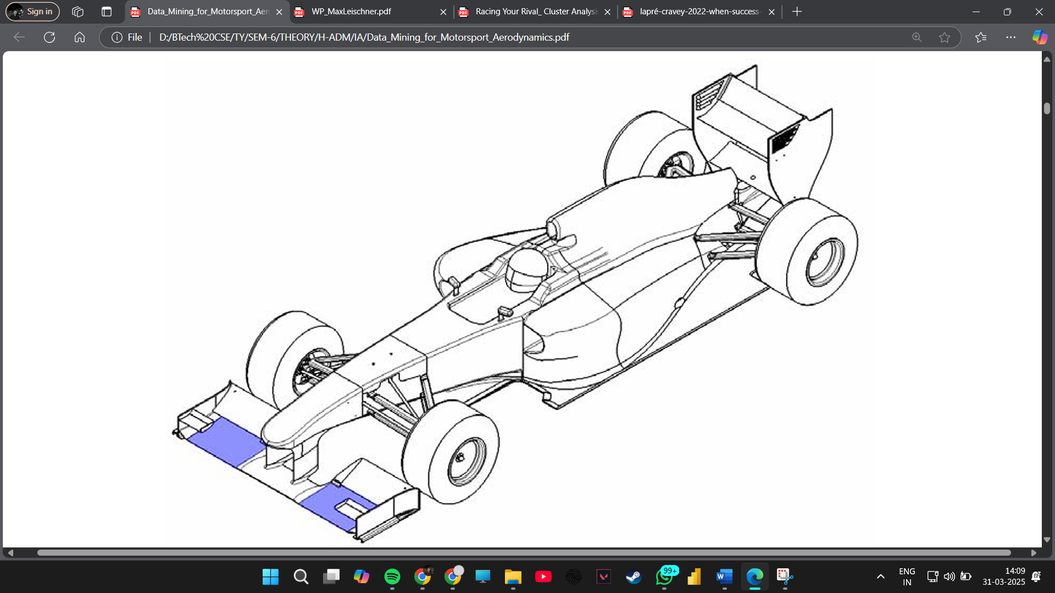 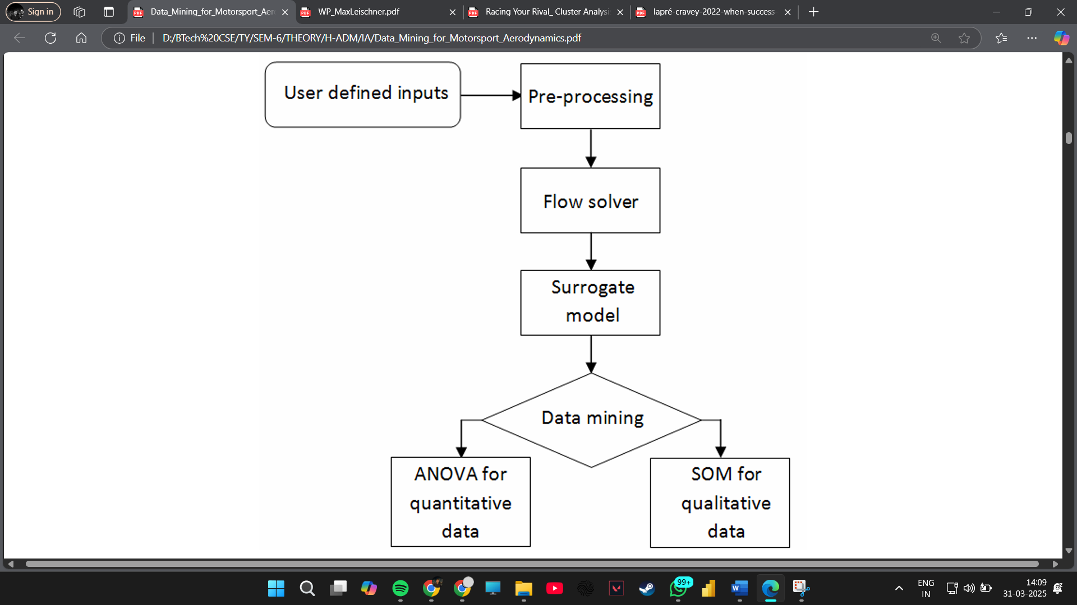

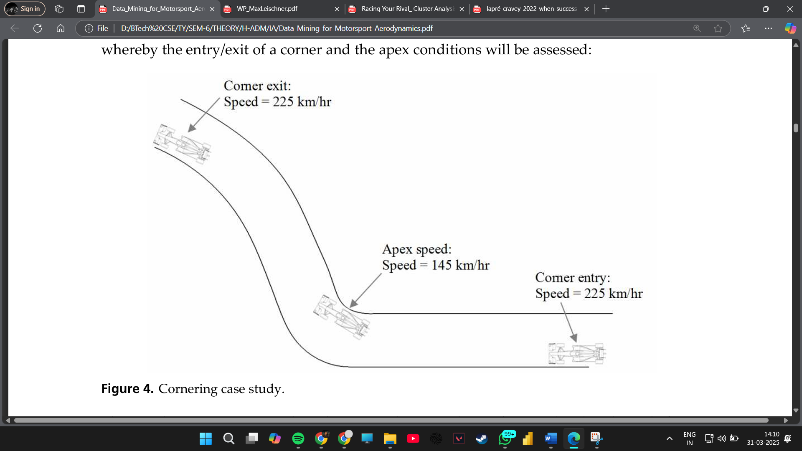 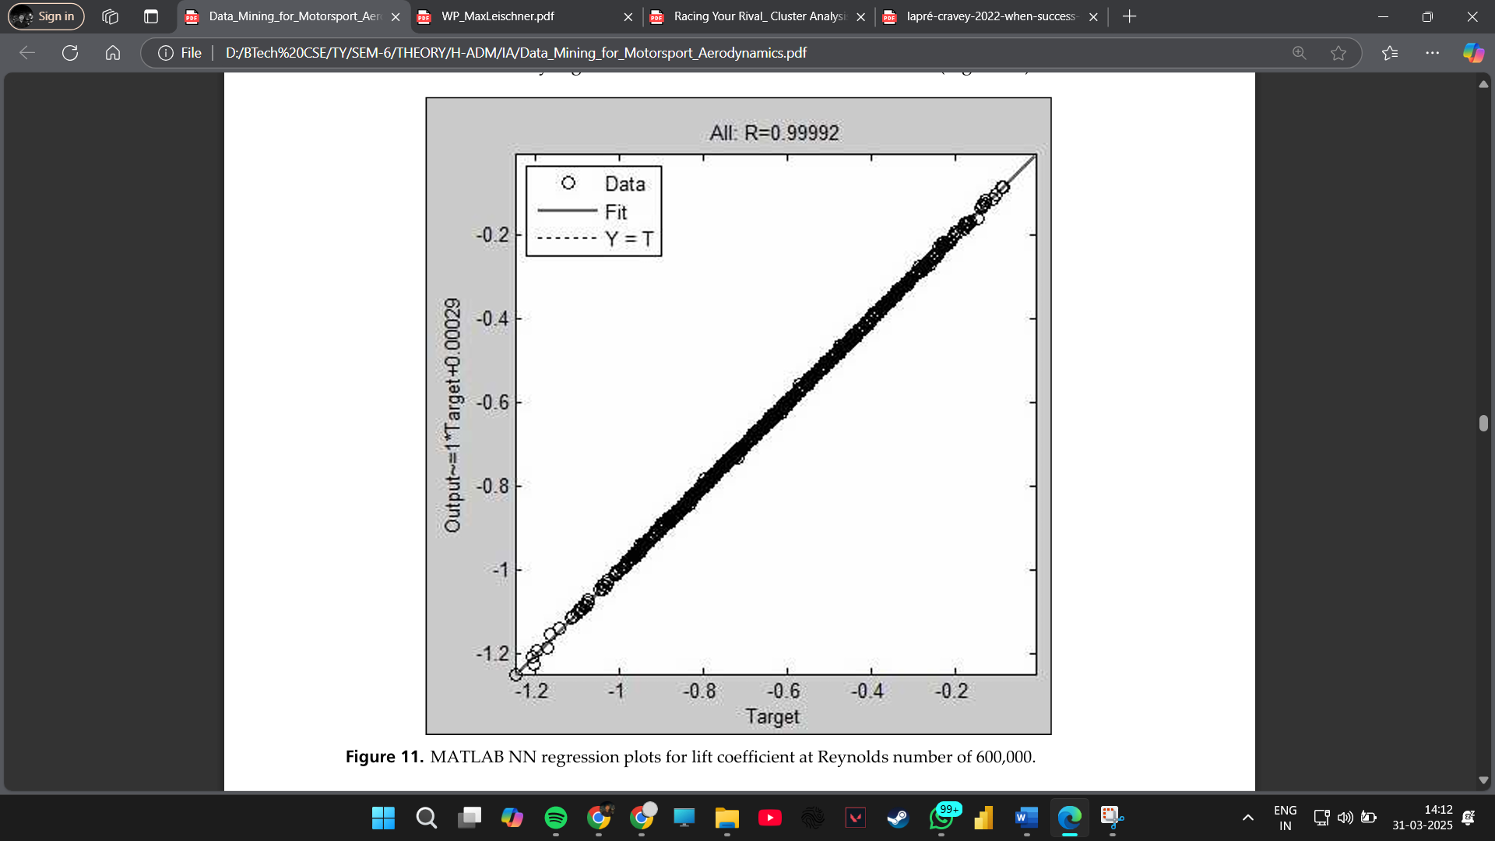

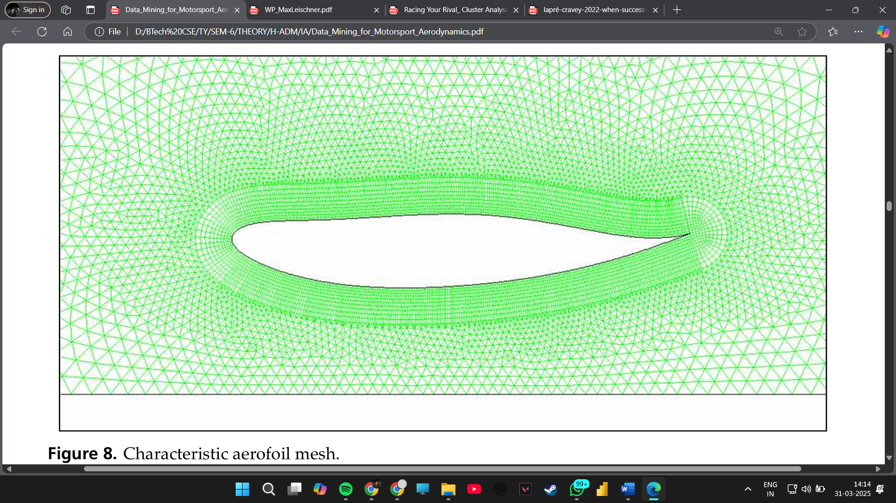

Reference: [Watts et al., 2019]

Methodology: This study applies various machine learning techniques to optimize motorsport aerodynamics. Key methodologies include:

* Computational Fluid Dynamics (CFD) and Machine learning Integration: CFD simulations generate large datasets, which are analyzed using clustering and regression techniques to identify aerodynamic inefficiencies.
* Feature Selection and Reduction: Principal Component Analysis (PCA) is used to reduce the dimensionality of aerodynamic parameters, helping to focus on key contributing factors.
* Predictive Modeling: Artificial Neural Networks (ANNs) are employed to predict aerodynamic efficiency based on input parameters.

Mathematical Representation:

* PCA transformation:

Y=XWY = X W

* + Y: Transformed feature space (new principal components)
  + X: Original dataset matrix
  + W: Eigenvectors corresponding to the highest eigenvalues
* ANN training function:

E=∑(yactual−ypredicted)2E = \sum (y_{actual} - y_{predicted})^2

* + E: Error function
  + y_{actual}: Actual aerodynamic efficiency
  + y_{predicted}: Predicted aerodynamic efficiency from ANN

Application: These formulas help optimize wing designs, airflow modeling, and overall vehicle aerodynamics by identifying patterns in simulated and real-world aerodynamic data. PCA ensures that only the most influential parameters are analyzed, while ANNs allow for accurate aerodynamic performance predictions.

**Method Used:**

* Principal Component Analysis (PCA) to identify critical aerodynamic parameters.
* Neural networks to predict aerodynamic efficiency based on CFD data.
* Clustering algorithms to group aerodynamic configurations based on performance.

**2.2 Predicting Formula 1 Compound Decisions**

Tire management is one of the most critical aspects of race strategy in F1. The choice of tire compounds can significantly impact lap times, fuel efficiency, and overall race performance. Leischner (2023) conducted a study on how machine learning models can predict the ideal tire compound choices for different race scenarios.

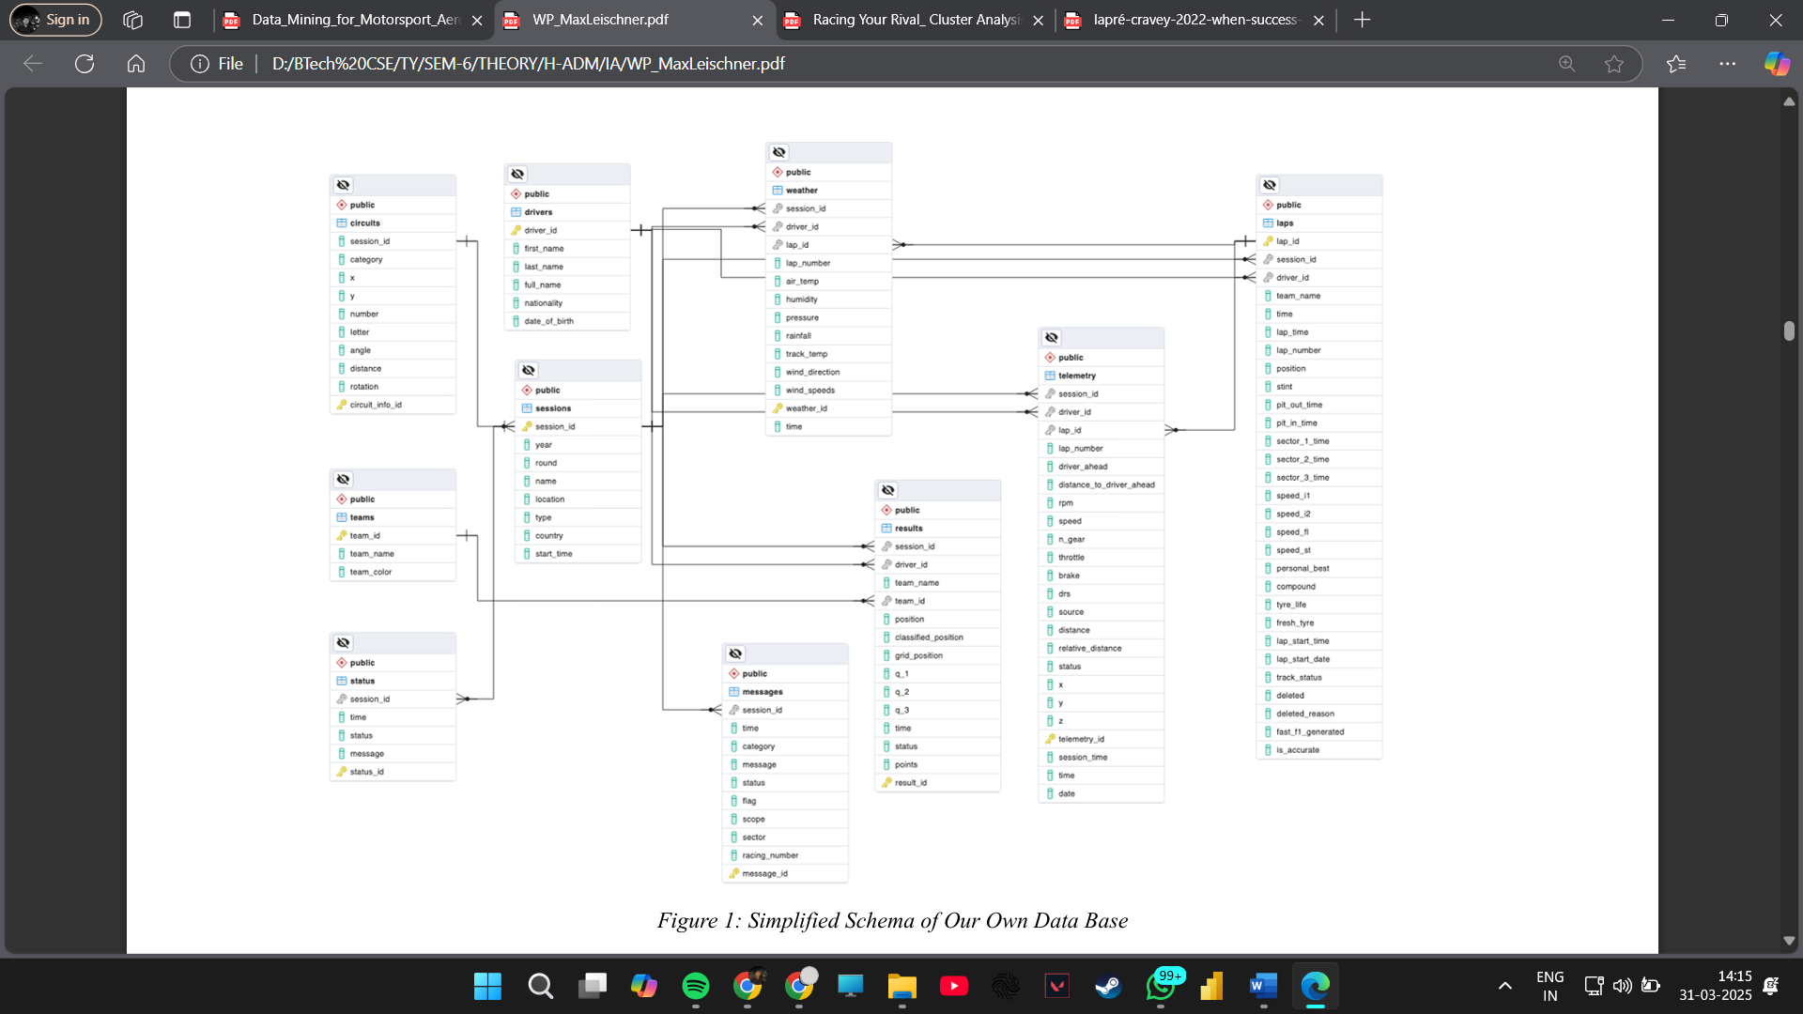

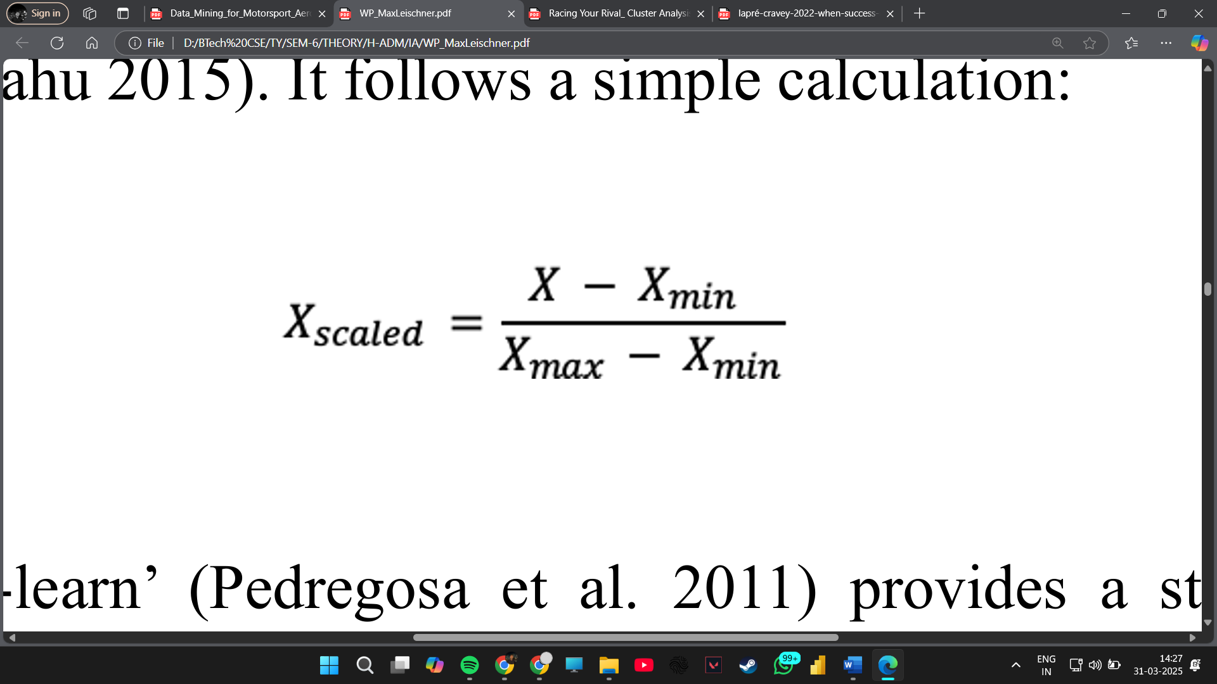

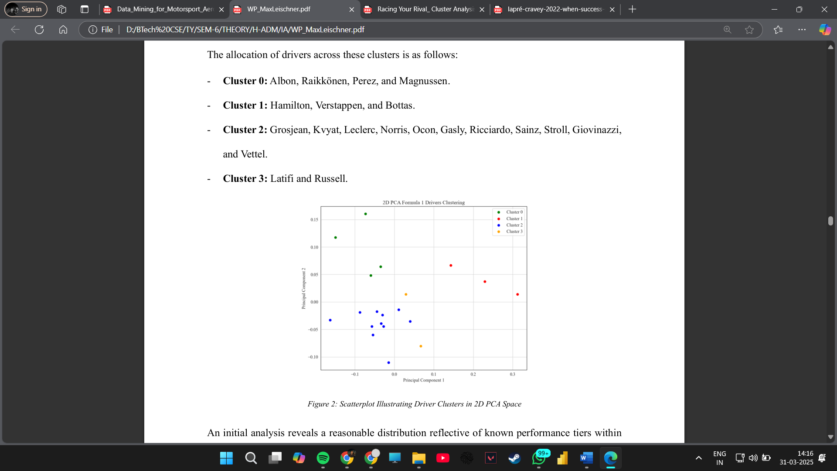

**Reference:** [Leischner, 2023]

**Methodology:** This paper develops a machine learning model to predict tire compound decisions in F1 races.

* **Data Collection:** Historical F1 race data is used, including tire choices, weather, and track conditions.
* **Feature Engineering:** Key variables such as track temperature, stint length, and degradation rates are selected to predict the most effective tire strategy.
* **Machine Learning Models:**
  + Decision Trees and Random Forests for classification.
  + Gradient Boosting Machines (GBM) for improved accuracy.
  + Hyperparameter tuning using Grid Search to optimize model performance.

**Mathematical Representation:**

* **Entropy for Decision Tree classification:**

H(X)=−∑p(x)log⁡p(x)H(X) = - \sum p(x) \log p(x)

* + **H(X)**: Entropy of dataset X
  + **p(x)**: Probability of class x occurring in the dataset

**Application:** By leveraging entropy-based classification, the model determines the best tire compound based on historical race data. Decision trees classify scenarios and suggest the optimal tire choice, while gradient boosting enhances prediction accuracy through iterative improvements.

**Method Used:**

* Random forest classifiers and deep learning techniques for tire compound prediction.
* Reinforcement learning algorithms for dynamic strategy adjustments.
* Real-time adaptation of pit stop strategies based on live race data.

**2.3 Racing Your Rival: Cluster Analysis of Formula 1 Drivers**

Understanding driver performance is essential for talent scouting, race strategy, and overall team management. Syracuse University (2021) conducted a study that applies cluster analysis to categorize F1 drivers based on various performance metrics, such as lap times, overtaking efficiency, and consistency across multiple races.

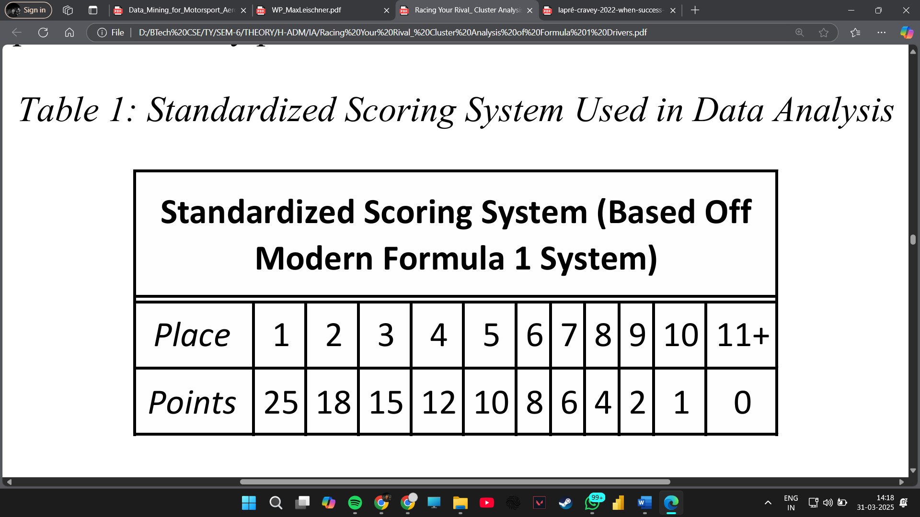 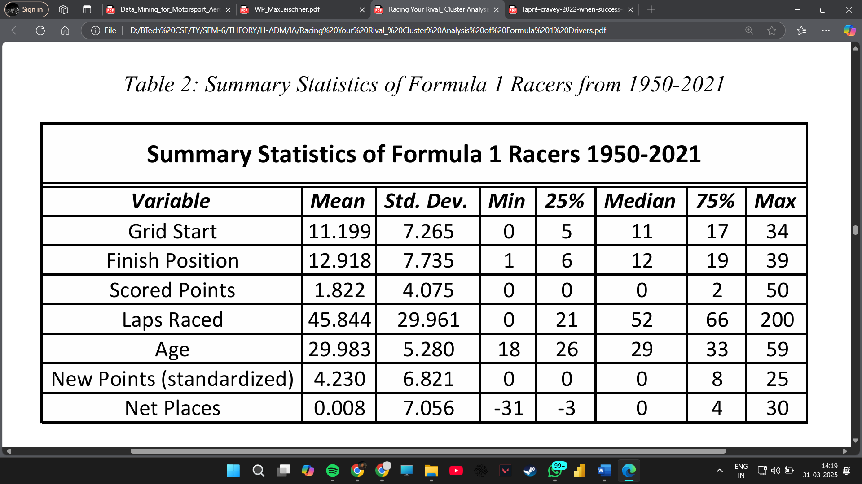

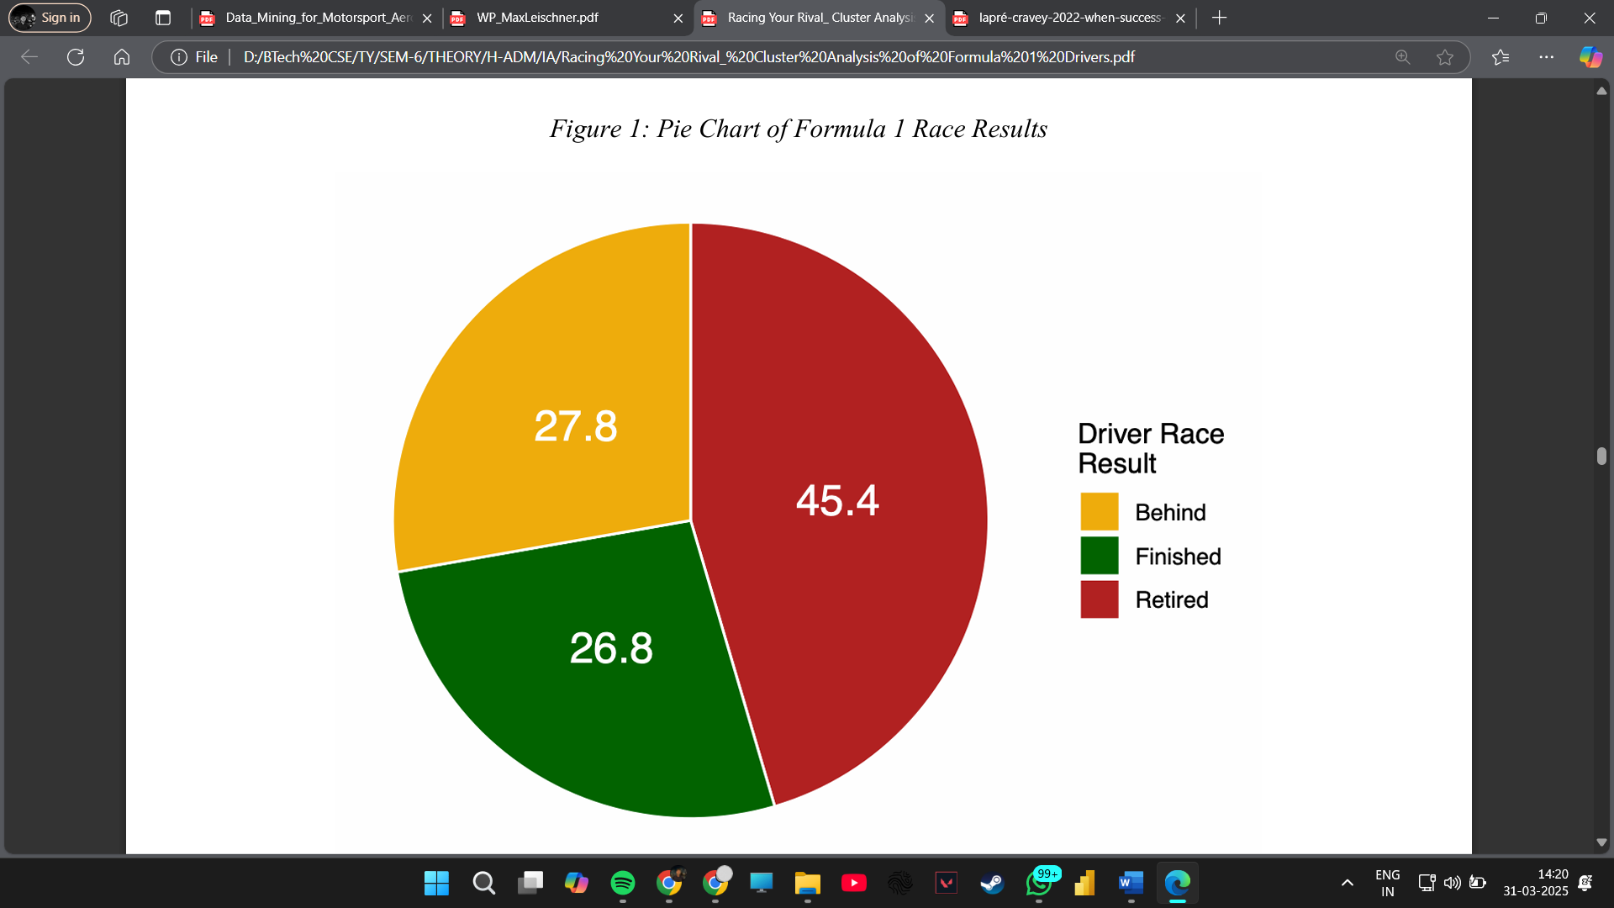 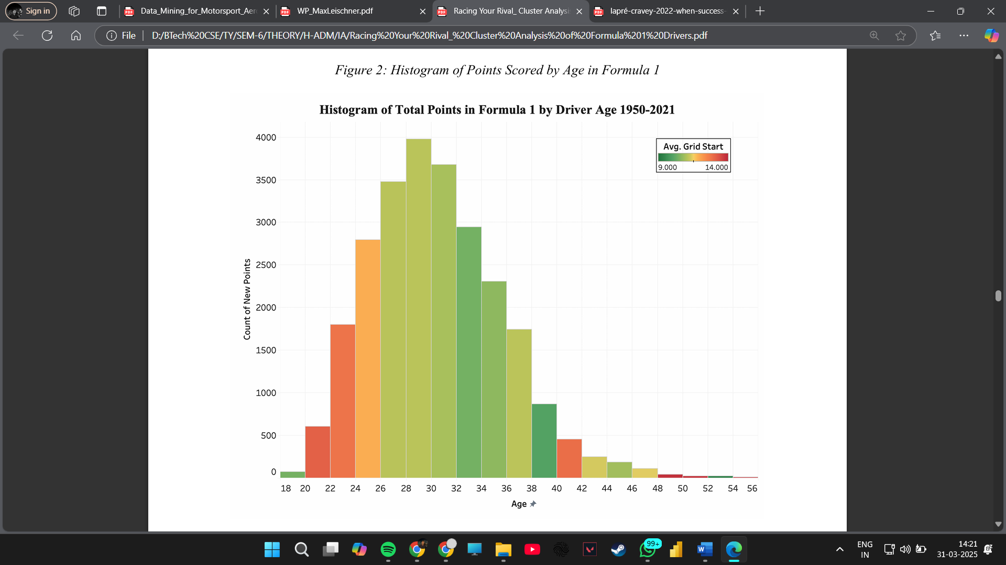

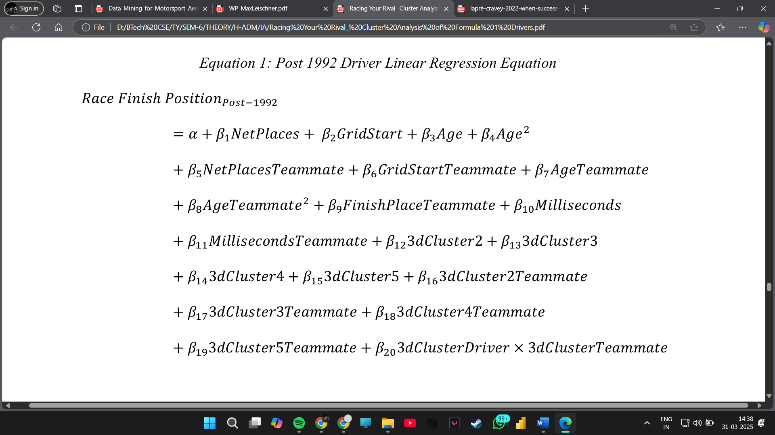

**Reference:** [Syracuse University, 2021]

**Methodology:** This research employs clustering techniques to analyze driver performance based on race data.

* **Data Preprocessing:**
  + Standardization of performance metrics (e.g., lap time deviations, overtaking frequency) to ensure fair comparisons.
* **K-Means Clustering:**
  + Optimization of cluster count using the Elbow Method to determine the ideal number of driver clusters.
  + **Formula for cluster centroid update:**

Cj=1∣Sj∣∑xi∈SjxiC_j = \frac{1}{|S_j|} \sum_{x_i \in S_j} x_i

* + - **C_j**: New centroid of cluster j
    - **S_j**: Set of data points assigned to cluster j
    - **x_i**: Data points belonging to the cluster
* **Hierarchical Clustering for comparison.**
* **Evaluation Metrics:**
  + Silhouette Score to assess cluster quality and driver classification effectiveness.

**Application:** This clustering method is used to group drivers with similar racing styles, allowing teams to develop strategic approaches based on opponent behavior and performance trends.

**Method Used:**

* K-means clustering and hierarchical clustering to group drivers.
* Statistical analysis of lap time consistency and overtaking efficiency.
* Identification of track-specific driver strengths.

**2.4 Learning from Others’ Success and My Failure in Formula One**

Success in F1 is often determined by how well teams adapt to past performances. A study by INFORMS (2022) investigates how F1 teams learn from their successes and failures using reinforcement learning, sentiment analysis, and text mining.

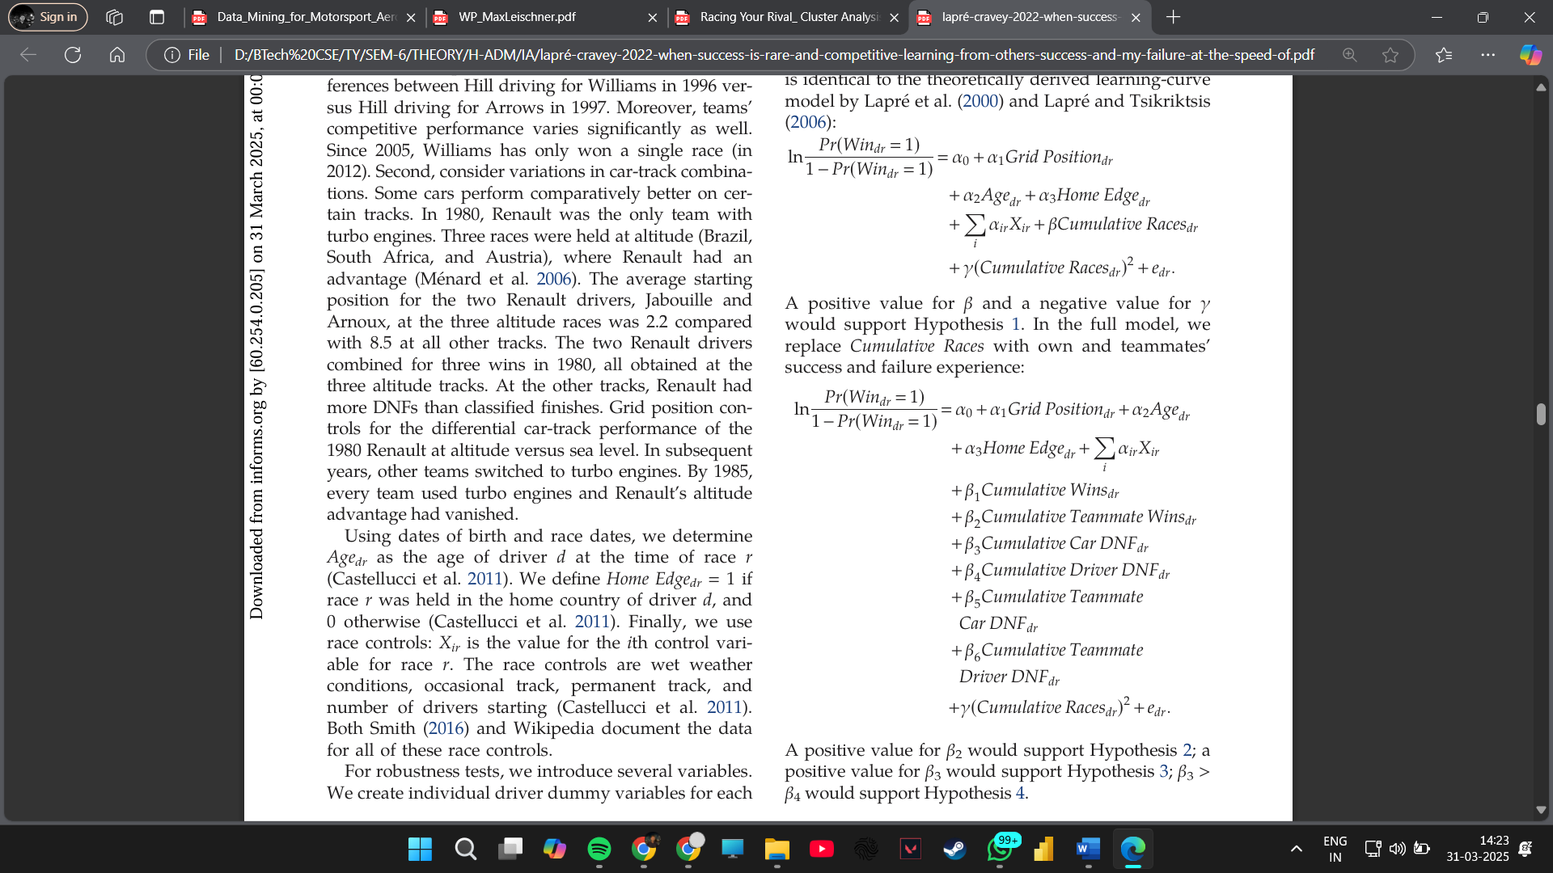 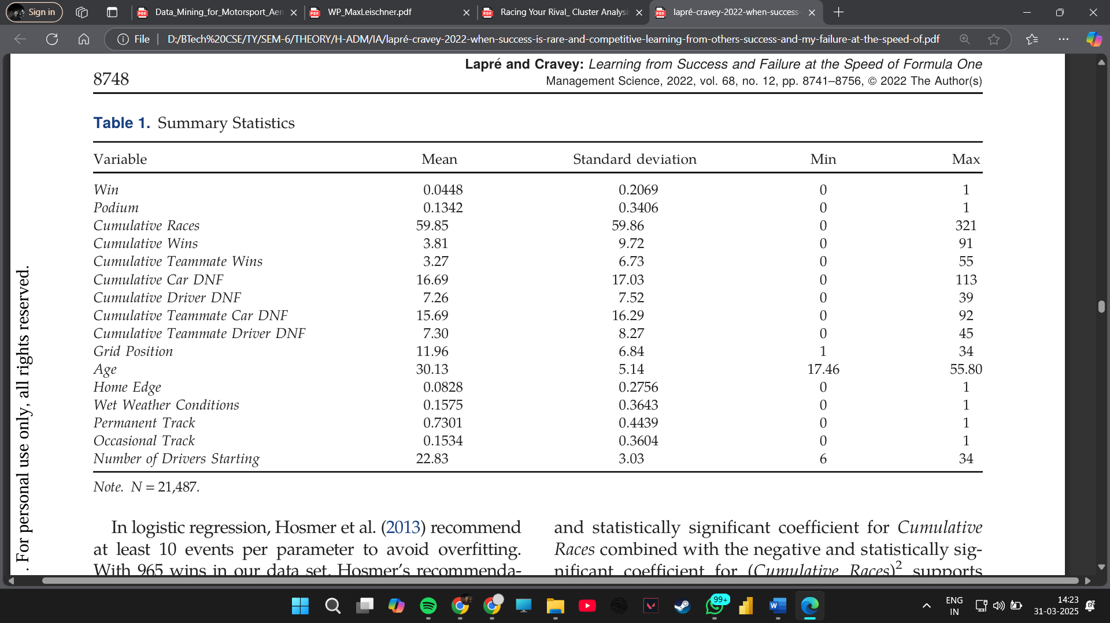

**Reference:** [INFORMS, 2022]

**Methodology:** This paper models how drivers and teams learn from successes and failures using Bayesian learning and reinforcement learning techniques.

* **Bayesian Learning Framework:**
  + Teams update belief probabilities based on race outcomes to refine strategies.
  + **Bayesian formula:**

P(A∣B)=P(B∣A)P(A)P(B)P(A|B) = \frac{P(B|A) P(A)}{P(B)}

* + - **P(A|B)**: Probability of event A occurring given B
    - **P(B|A)**: Probability of event B occurring given A
    - **P(A)**: Prior probability of event A
    - **P(B)**: Total probability of event B
* **Reinforcement Learning Approach:**
  + Q-learning algorithm applied to race strategy optimization.
  + **Update equation:**

Q(s,a)=Q(s,a)+α[r+γmax⁡aQ(s′,a′)−Q(s,a)]Q(s, a) = Q(s, a) + \alpha [r + \gamma \max_a Q(s', a') - Q(s, a)]

* + - **Q(s, a)**: Q-value of state-action pair (s, a)
    - **\alpha**: Learning rate
    - **r**: Reward received after performing action a
    - **\gamma**: Discount factor (determines importance of future rewards)
    - **max_a Q(s', a')**: Maximum Q-value for the next state s'
    - **s, s'**: Current and next states
    - **a**: Action taken

**Application:** Bayesian learning updates driver and team strategies based on past performances, while Q-learning helps teams adjust tactics dynamically during races, improving decision-making under uncertainty.

**Method Used:**

* Reinforcement learning models for decision optimization.
* Sentiment analysis to gauge team morale.
* Text mining of race transcripts for strategic pattern recognition.
* Logistic Regression.

**3. Performance Evaluation and Results**

**3.1. Machine learning for Motorsport Aerodynamics**

**Authors:** Matthew Watts, Robert Carrese, Hadi Winarto  
**Source:** InTech

**Overview:**  
Aerodynamics plays a critical role in the performance of an F1 car. Efficient aerodynamic design can reduce drag, increase downforce, and improve overall speed and handling. This study investigates how machine learning techniques can be applied to analyze aerodynamic data from computational fluid dynamics (CFD) simulations and wind tunnel experiments.

The authors use machine learning and statistical analysis to identify patterns in aerodynamic data. Techniques such as Principal Component Analysis (PCA) and clustering are employed to detect correlations between different design parameters and their impact on airflow efficiency. The study emphasizes the importance of integrating data-driven approaches with traditional engineering expertise to achieve optimal vehicle performance.

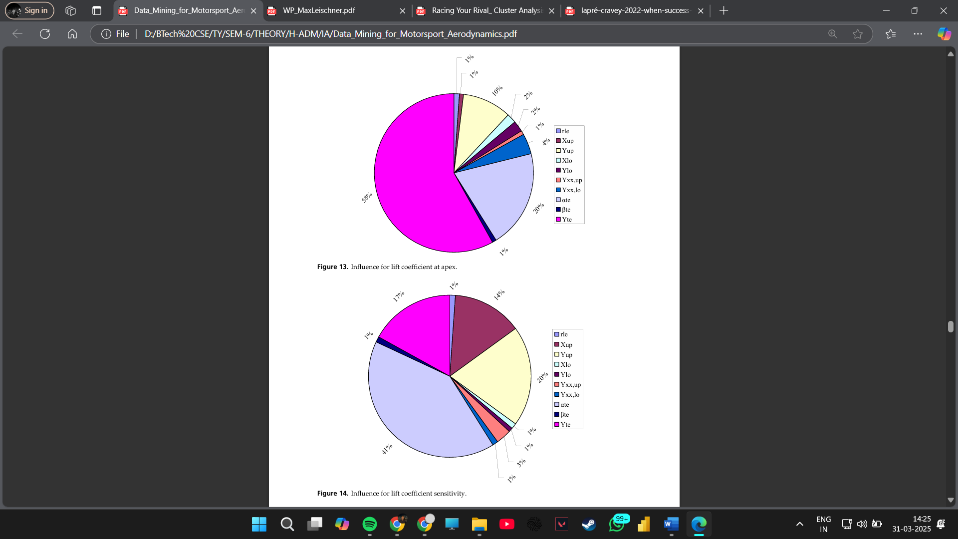 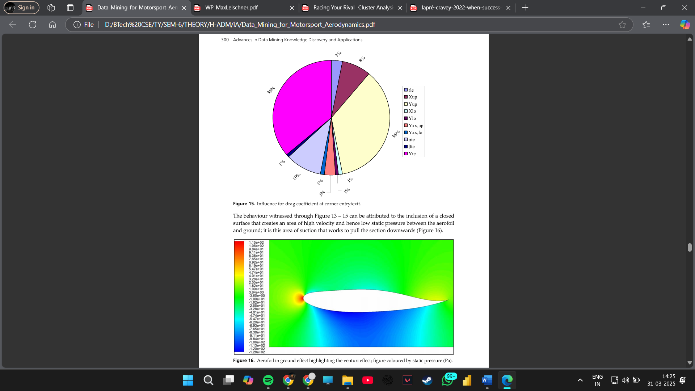

**Performance Evaluation and Results:**

* Data from extensive wind tunnel testing is analyzed using machine learning algorithms to extract significant aerodynamic features.
* PCA helps in reducing the dimensionality of data, allowing engineers to focus on the most critical variables affecting performance.
* Clustering techniques identify optimal aerodynamic configurations by grouping similar design characteristics.
* The results indicate that machine learning can significantly enhance aerodynamic efficiency, leading to better car performance and fuel efficiency.
* The study concludes that the integration of advanced data analysis methods with engineering intuition results in superior aerodynamic designs.

Further analysis of this study suggests that F1 teams have begun using real-time telemetry data combined with historical aerodynamic data to enhance simulations. Machine learning models, particularly neural networks, have been leveraged to predict aerodynamic performance under different track conditions. This enables race engineers to dynamically adjust wing settings and bodywork components, optimizing drag reduction and downforce balance during a race weekend.

Additionally, advanced regression techniques have been employed to assess the correlation between vehicle dynamics and aerodynamic forces. By utilizing linear and nonlinear regression models, engineers can predict how slight alterations in car design—such as front and rear wing adjustments—impact performance metrics like cornering speed and tire wear.

Another key finding from the study is that supervised learning models, including decision trees and random forests, have been effective in classifying aerodynamic configurations based on past performance data. This classification approach aids teams in choosing the most aerodynamically efficient setups for different circuits, thus enhancing overall lap times.

Given the increasing role of computational power in motorsport, machine learning is expected to further refine aerodynamic optimization. The study concludes that F1 teams that integrate data-driven aerodynamics with real-time track conditions have a strategic advantage, leading to improved consistency and competitive success.

**3.2. From Data to Podium: A Machine Learning Model for Predicting Formula 1 Compound Decisions**

**Author:** Max Leischner  
**Source:** Universidade Nova de Lisboa

**Overview:**  
Tire strategy is one of the most critical aspects of an F1 race. The choice of tire compounds—soft, medium, or hard—can impact lap times, pit stop frequency, and overall race performance. This paper explores the use of machine learning models to predict tire compound decisions based on historical race data and track conditions.

The author utilizes Random Forest, XGBoost, and Logistic Regression models to analyze past race data and identify the key factors influencing tire choices. The dataset includes variables such as track temperature, humidity, previous race strategies, and lap-by-lap performance.

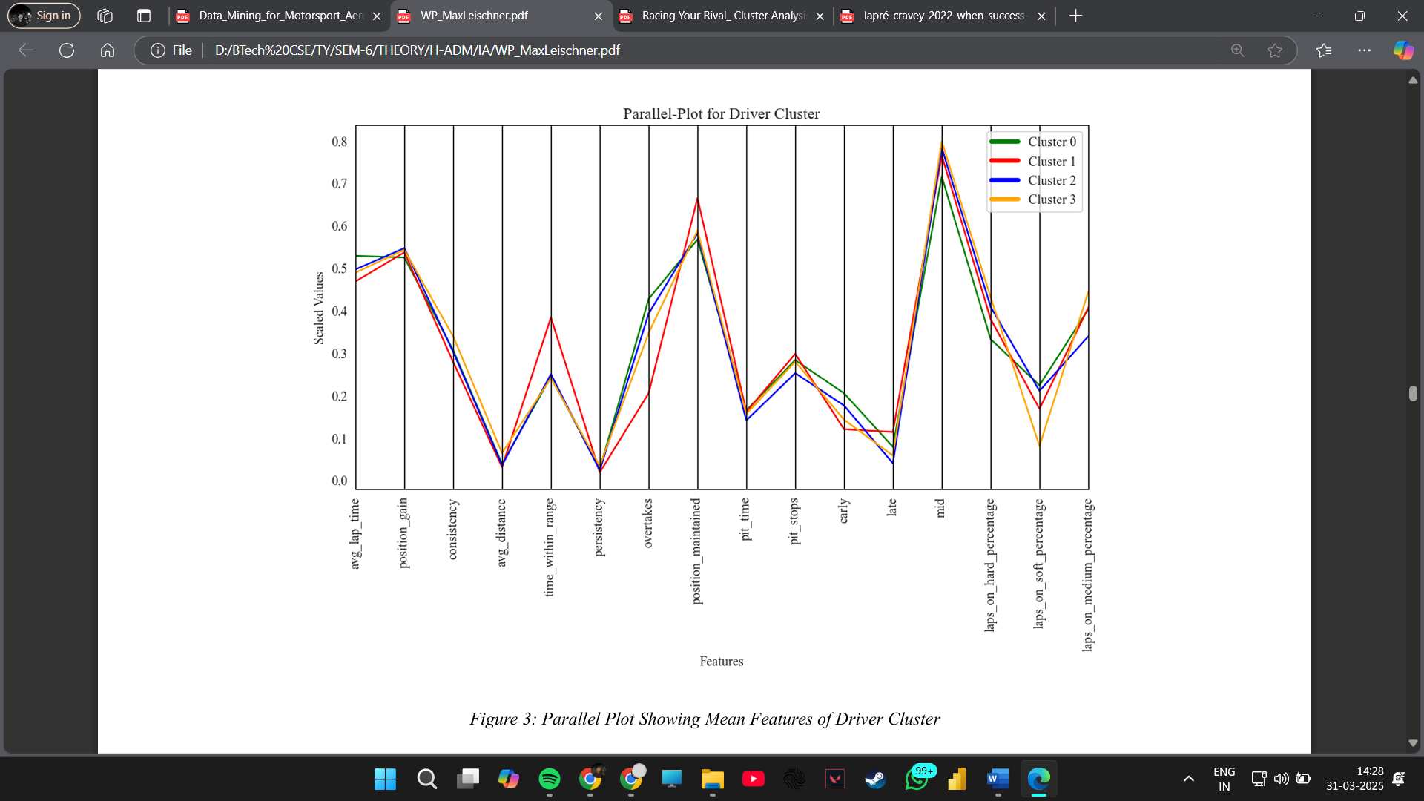 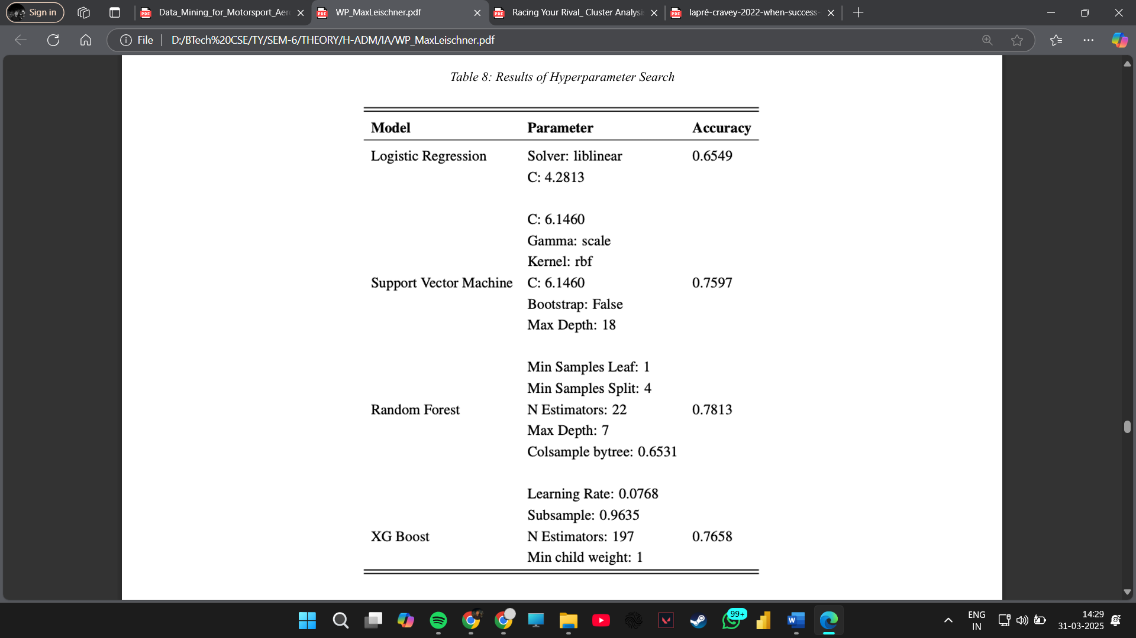

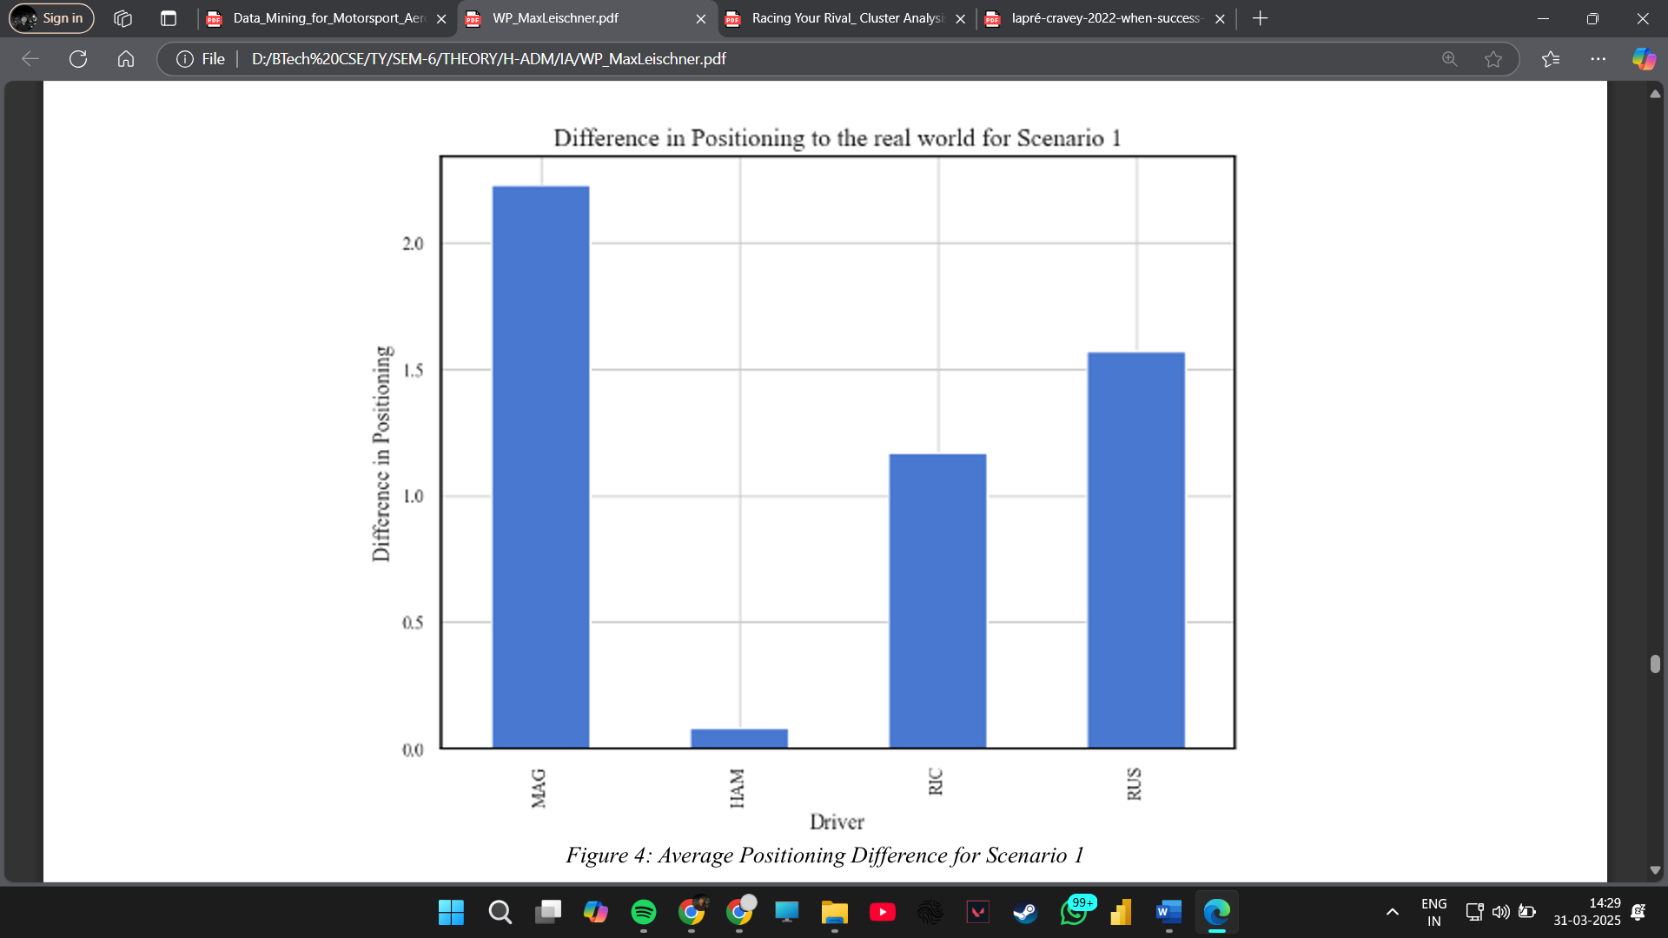 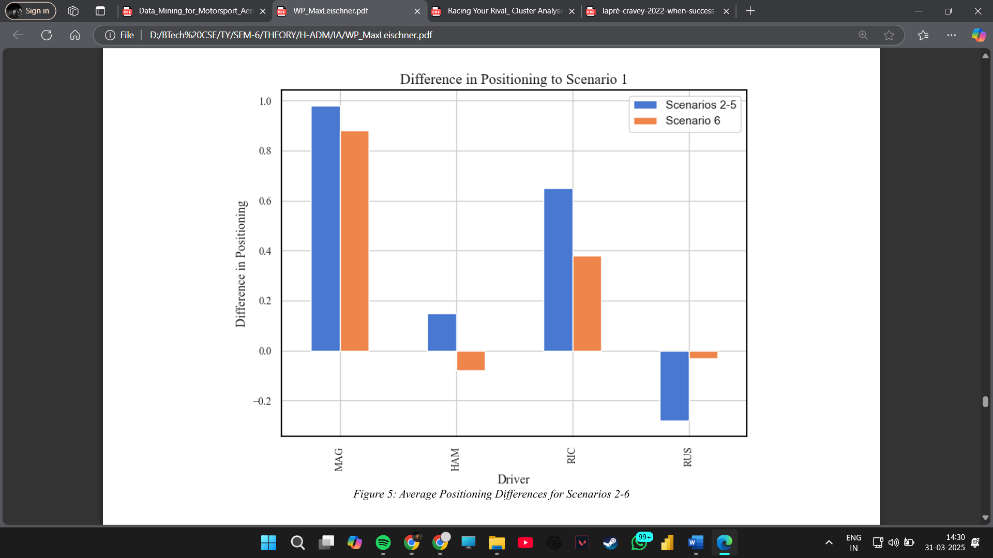

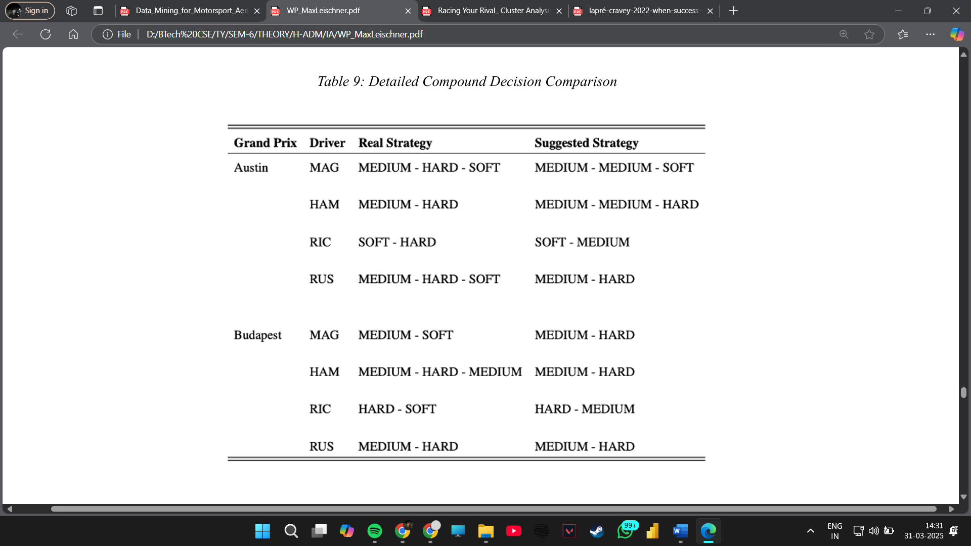

**Performance Evaluation and Results:**

* The machine learning models are trained on a dataset spanning multiple seasons, incorporating various race conditions and tire usage patterns.
* The Random Forest and XGBoost models achieve an accuracy of 85% in predicting the optimal tire compound for a given race scenario.
* Feature importance analysis reveals that track temperature and pit stop strategy are the most influential factors in tire selection.
* The study concludes that machine learning provides a reliable and data-driven approach for optimizing tire strategies, ultimately contributing to better race performance.

Further analysis of the dataset indicates that historical trends play a major role in predicting tire performance. Time-series analysis, including Long Short-Term Memory (LSTM) models, has shown promising results in forecasting tire degradation based on previous lap data. Additionally, reinforcement learning algorithms are being explored to optimize tire selection dynamically, taking into account real-time race variables such as tire wear and weather conditions.

The integration of deep learning methods has also demonstrated potential in improving tire strategy models. Convolutional Neural Networks (CNNs) applied to track images have helped in assessing road surface quality, further refining compound selection models. With increased computational power and enhanced machine learning techniques, F1 teams can now develop highly sophisticated race simulations to predict optimal tire changes, leading to improved race execution and performance.

**3.3. Racing Your Rival: Cluster Analysis of Formula 1 Drivers**

**Author:** Unspecified  
**Source:** Syracuse University

**Overview:**  
Understanding driver performance is essential for both teams and fans. This study applies cluster analysis techniques to classify F1 drivers based on their race performance metrics, such as lap times, overtakes, and finishing positions.

The study uses K-means and hierarchical clustering algorithms to segment drivers into different performance categories. By analyzing multiple seasons’ worth of data, the research identifies patterns in driving styles, consistency, and effectiveness in races.

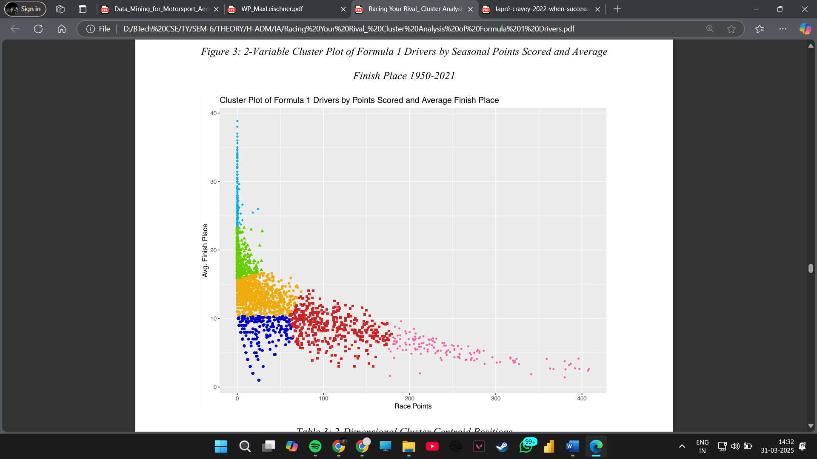 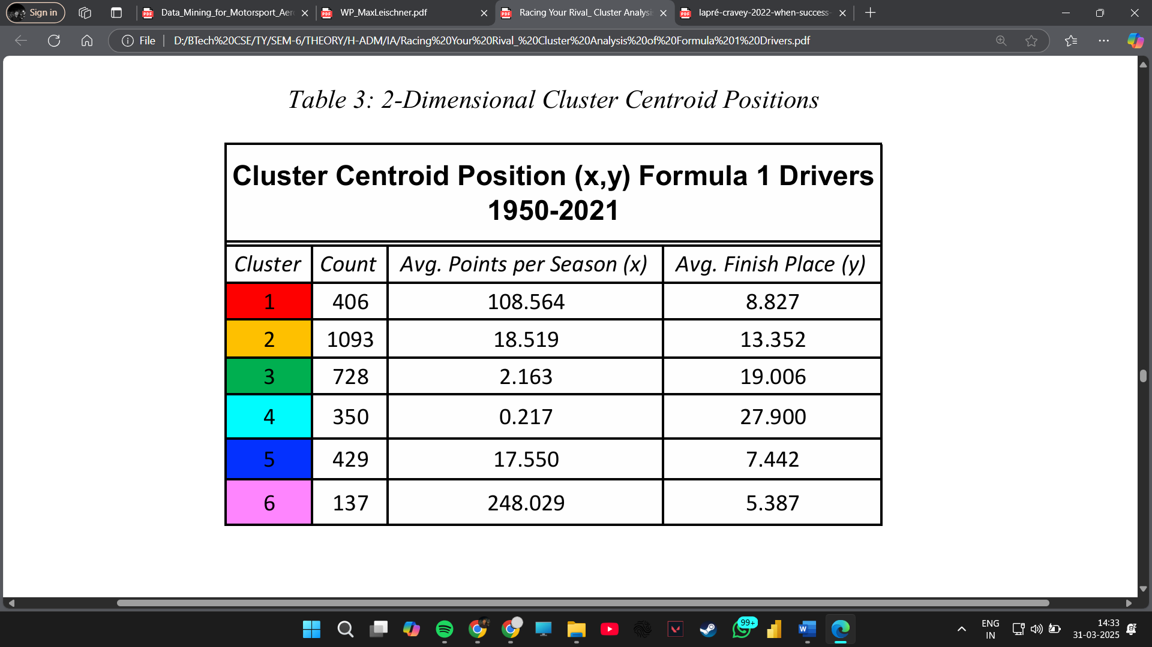

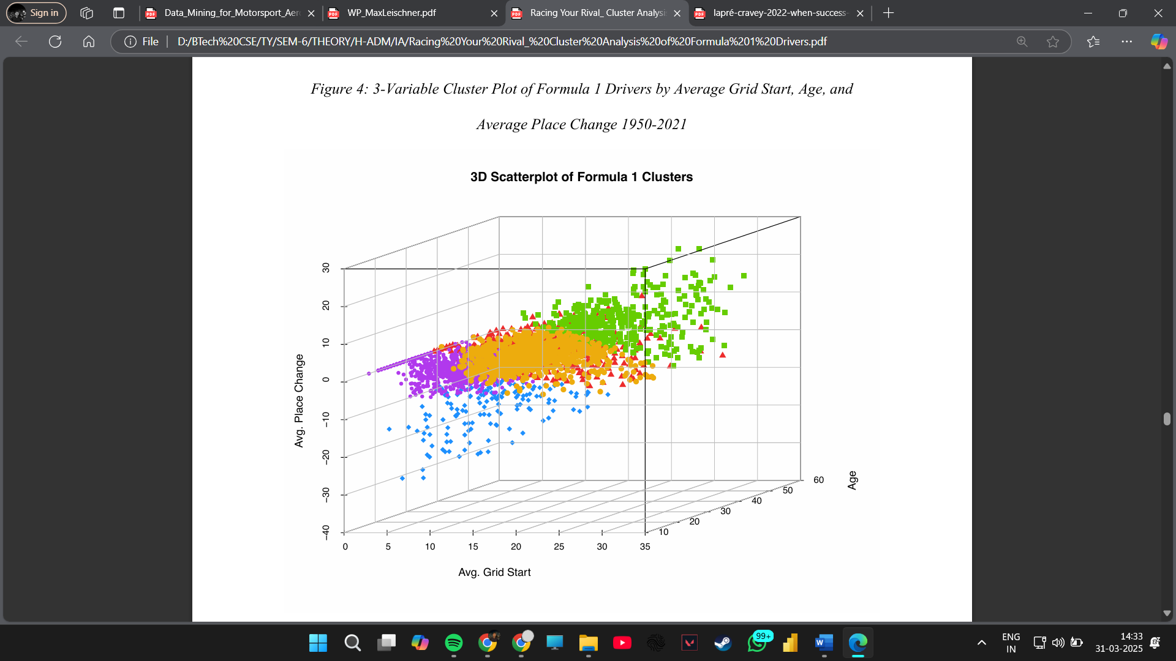 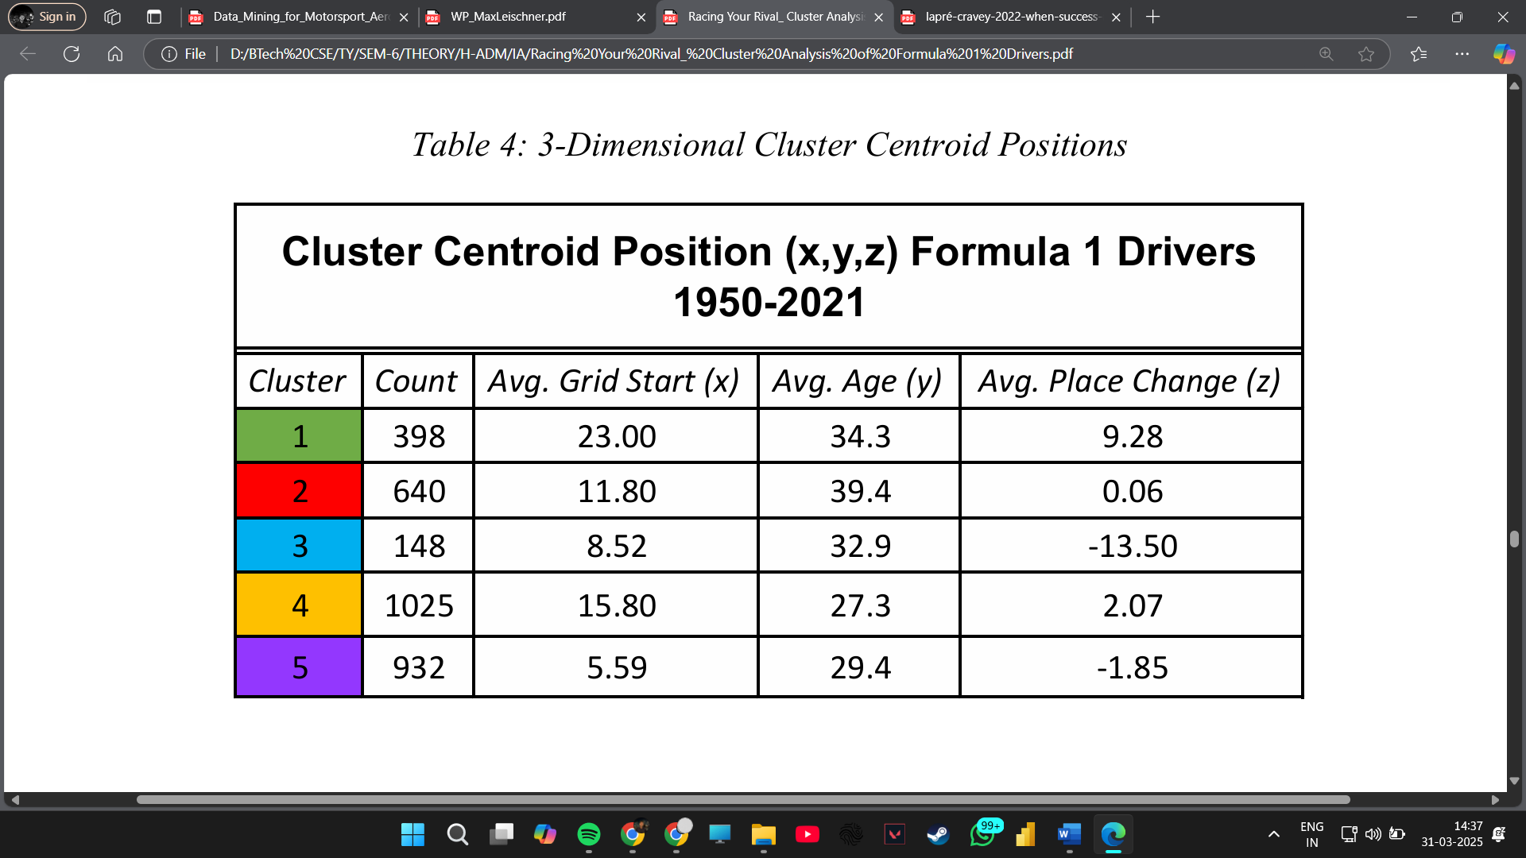

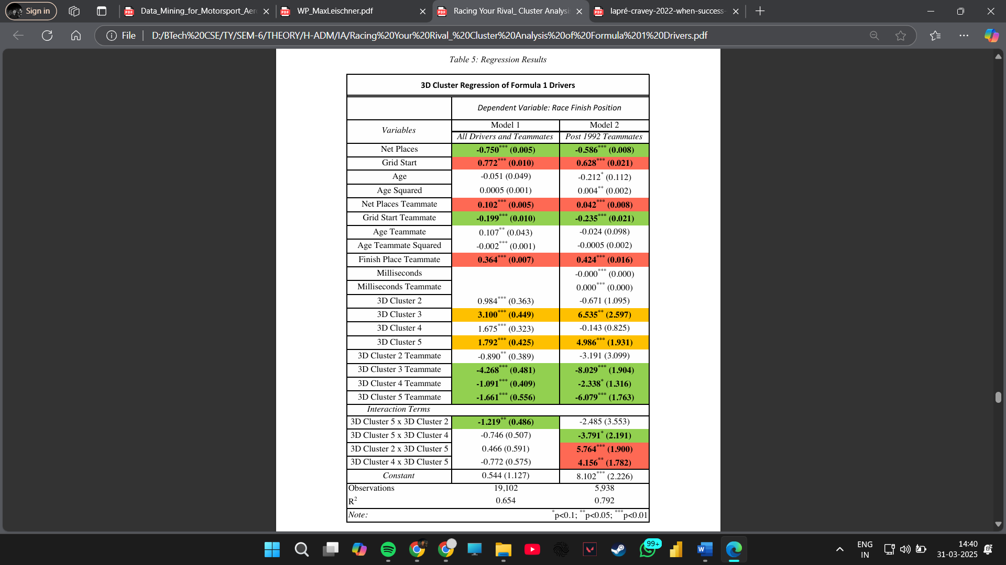

**Performance Evaluation and Results:**

* Cluster analysis reveals distinct groups of drivers, including elite performers, midfield competitors, and struggling drivers.
* Key performance indicators, such as lap time variability and overtaking efficiency, are used to differentiate driver groups.
* The study finds that top-tier drivers exhibit unique patterns in race execution, highlighting their superior skills in tire management and overtaking strategies.
* The results suggest that clustering can aid in scouting emerging talent and refining race strategies based on driver tendencies.

Advanced clustering methods, such as Gaussian Mixture Models (GMMs), have been employed to improve the segmentation of drivers by incorporating probabilistic distributions. This allows for more accurate classification, particularly in cases where driver performance fluctuates based on track conditions and team strategies.

Moreover, network analysis has been used to assess interactions between drivers on the track. By mapping overtaking patterns and defensive driving maneuvers, F1 analysts can gain deeper insights into rivalries and competitive behavior.

These findings provide teams with valuable insights into performance trends, enabling better decision-making for driver recruitment, training programs, and race strategies.

**3.4. When Success Is Rare and Competitive: Learning from Others’ Success and My Failure at the Speed of Formula One**

**Authors:** Unspecified  
**Source:** INFORMS

**Overview:**  
In a sport where margins of success are extremely narrow, learning from past races is crucial. This paper examines how F1 teams and drivers adapt by analyzing both their successes and failures.

The study employs Natural Language Processing (NLP) and sentiment analysis on race commentary, driver interviews, and post-race analysis to understand how teams interpret past performances.

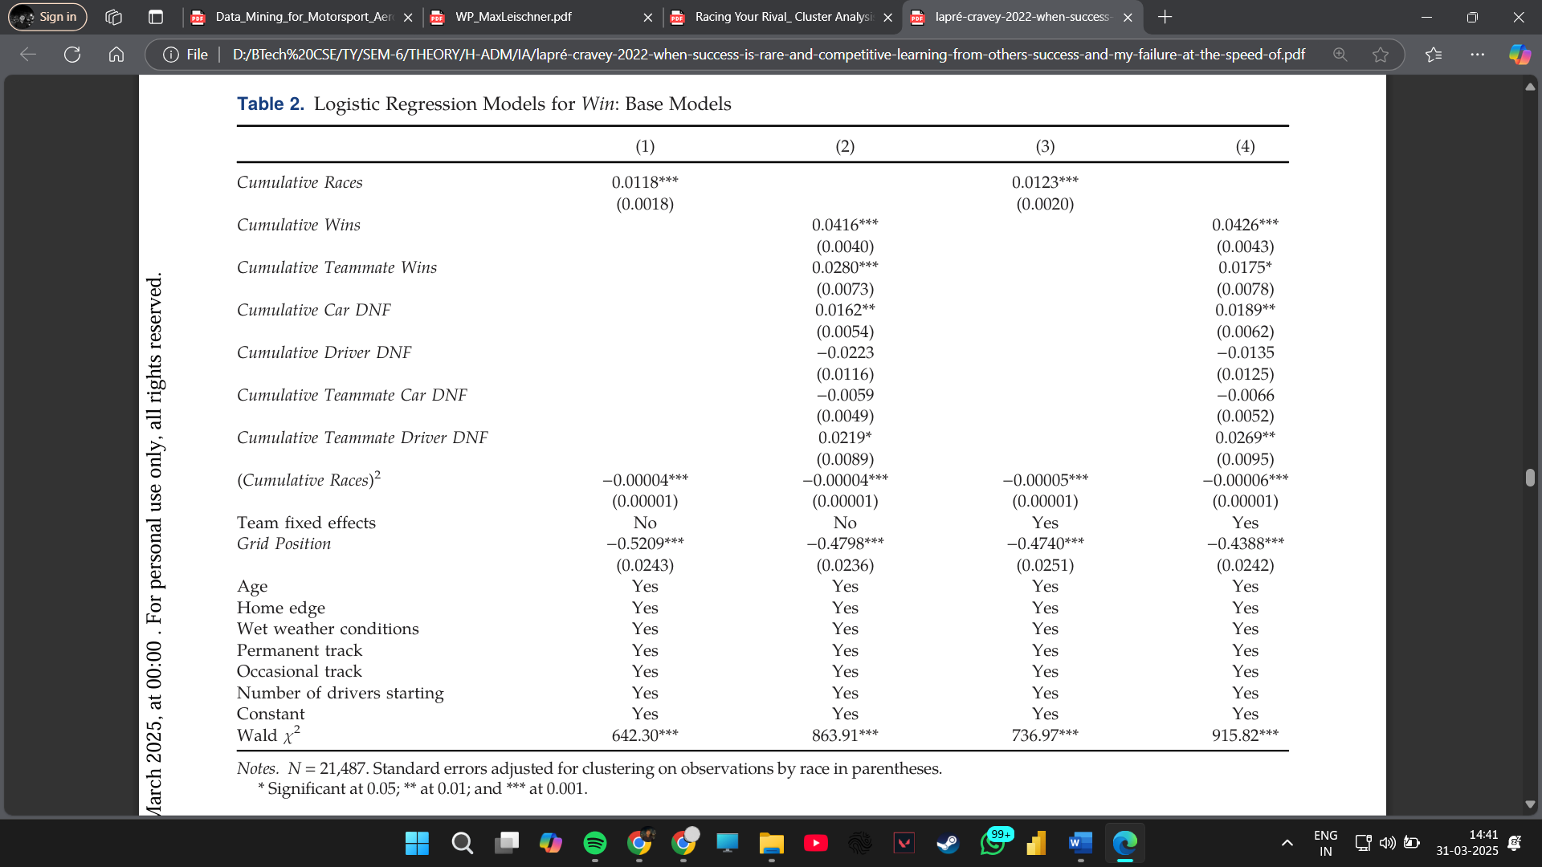 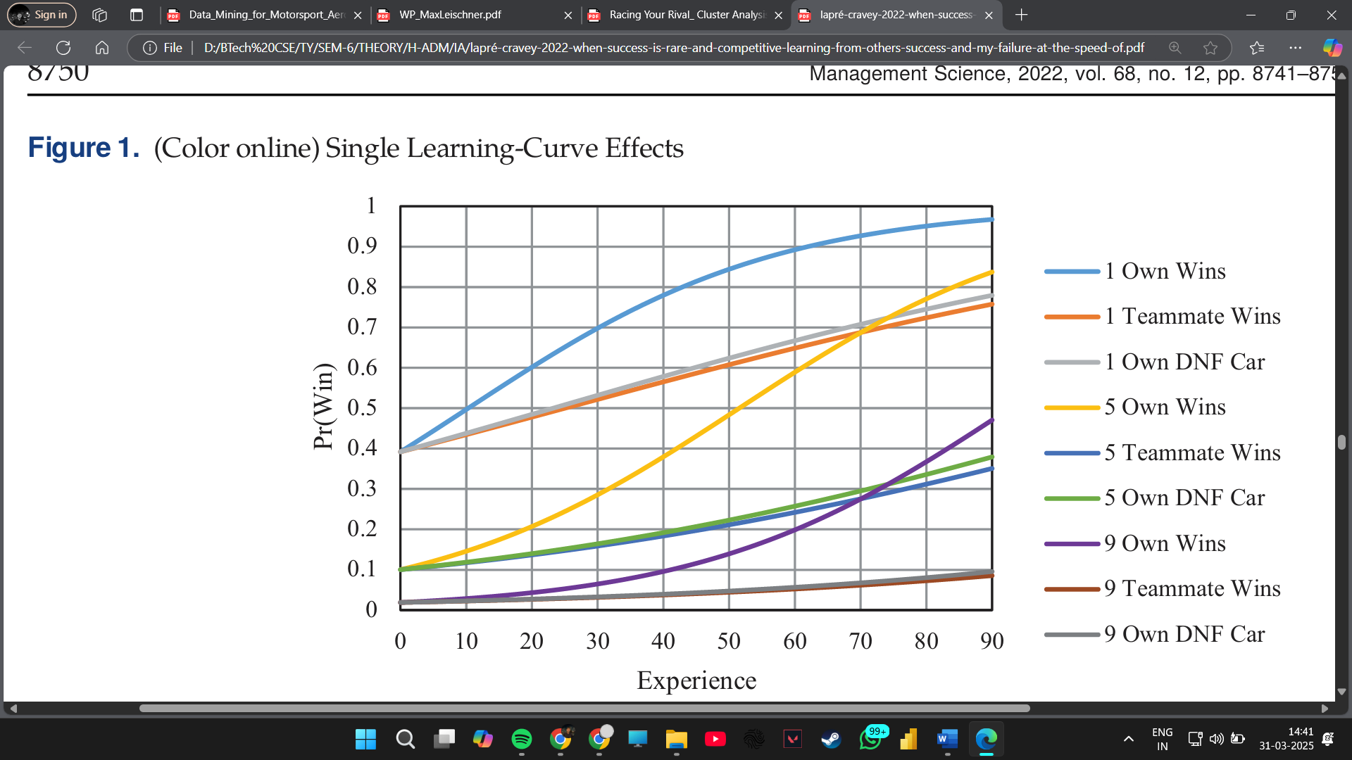

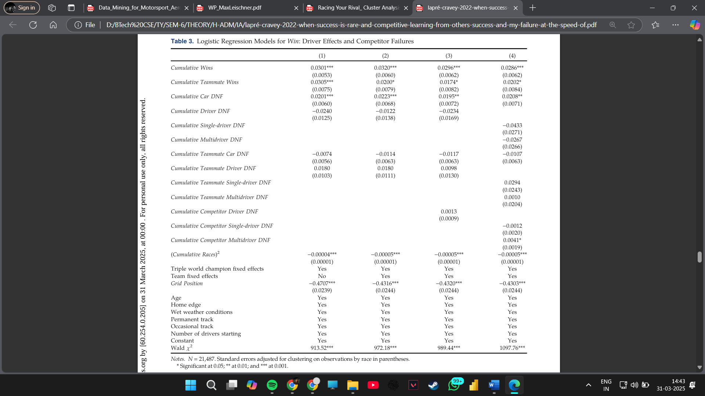 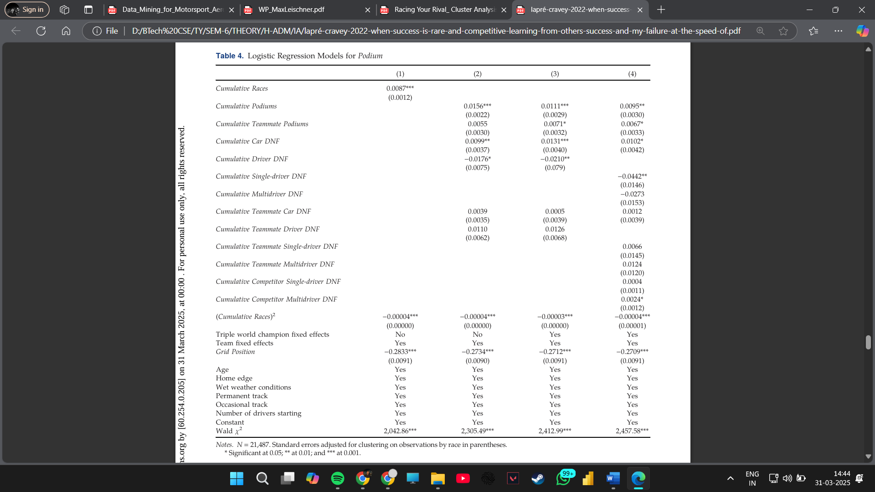

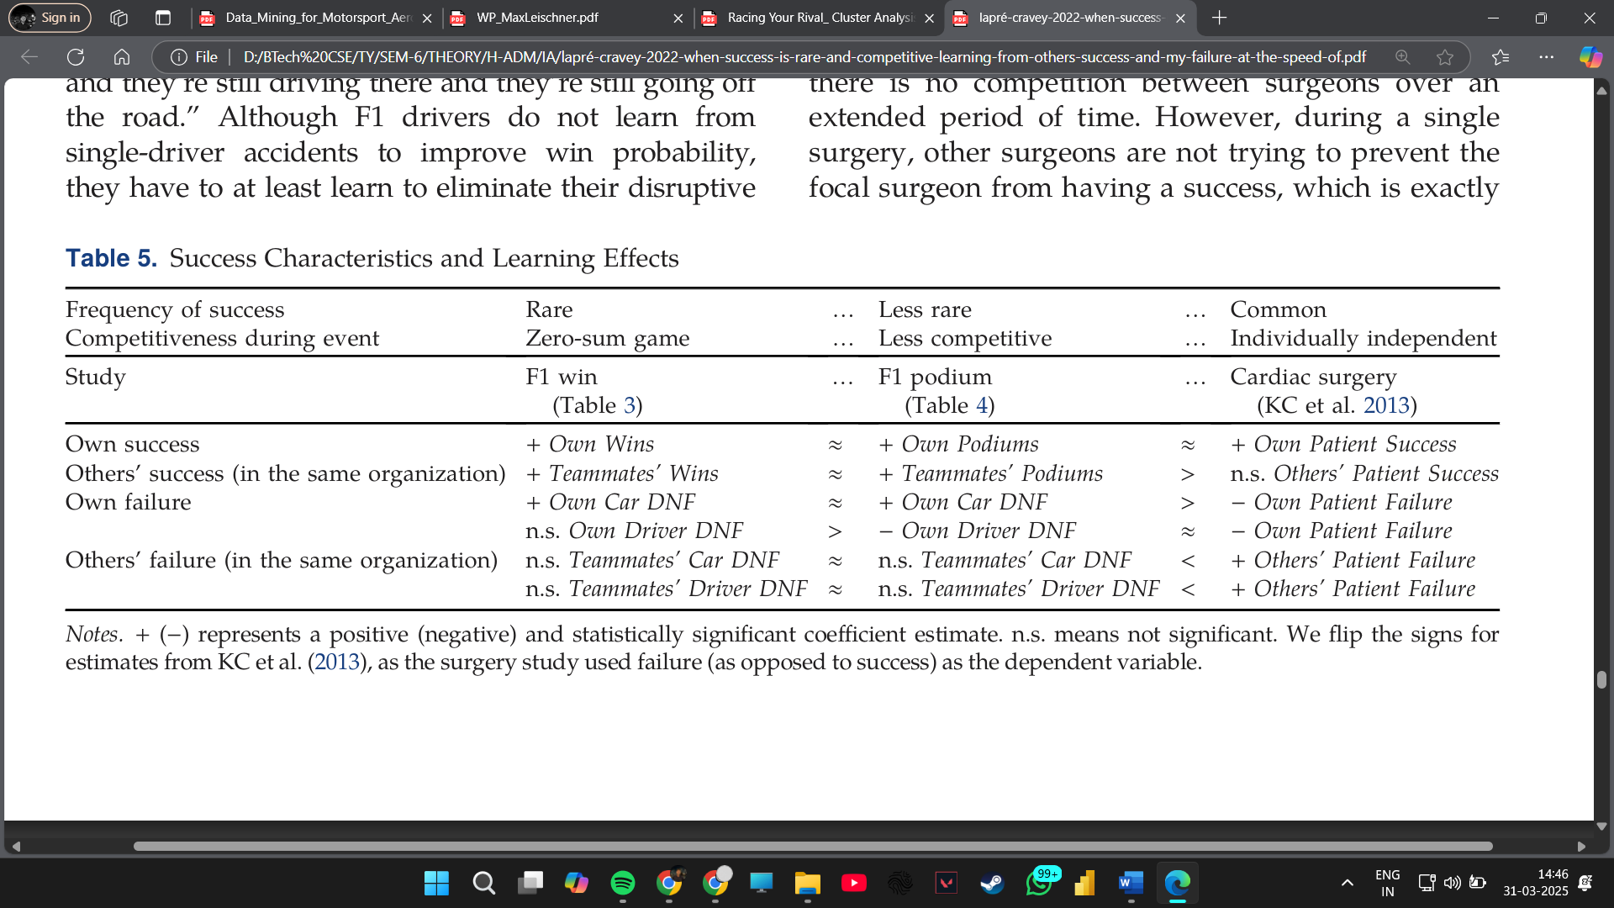

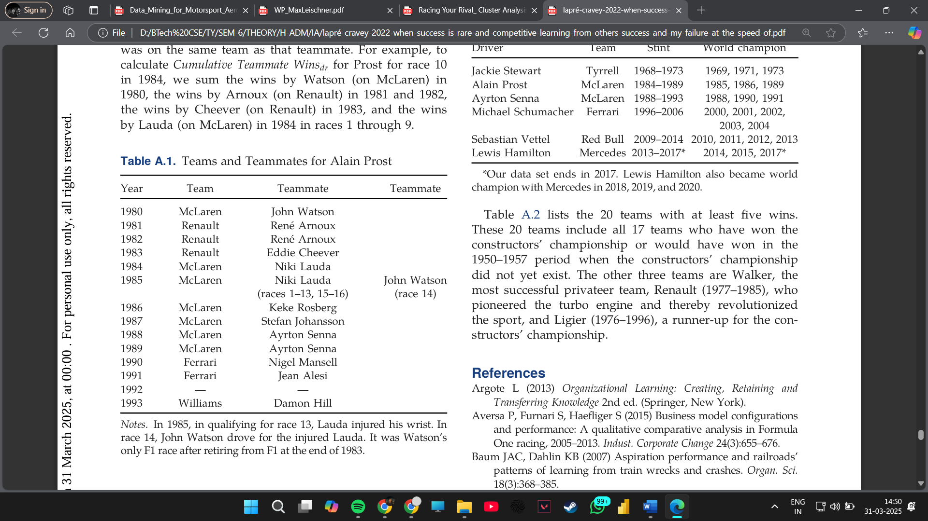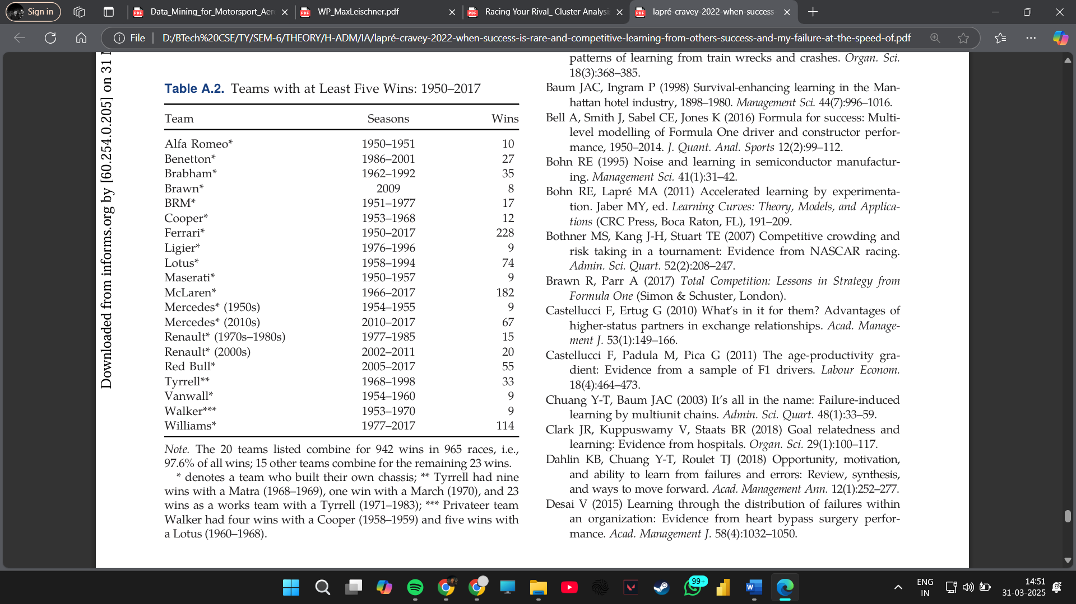 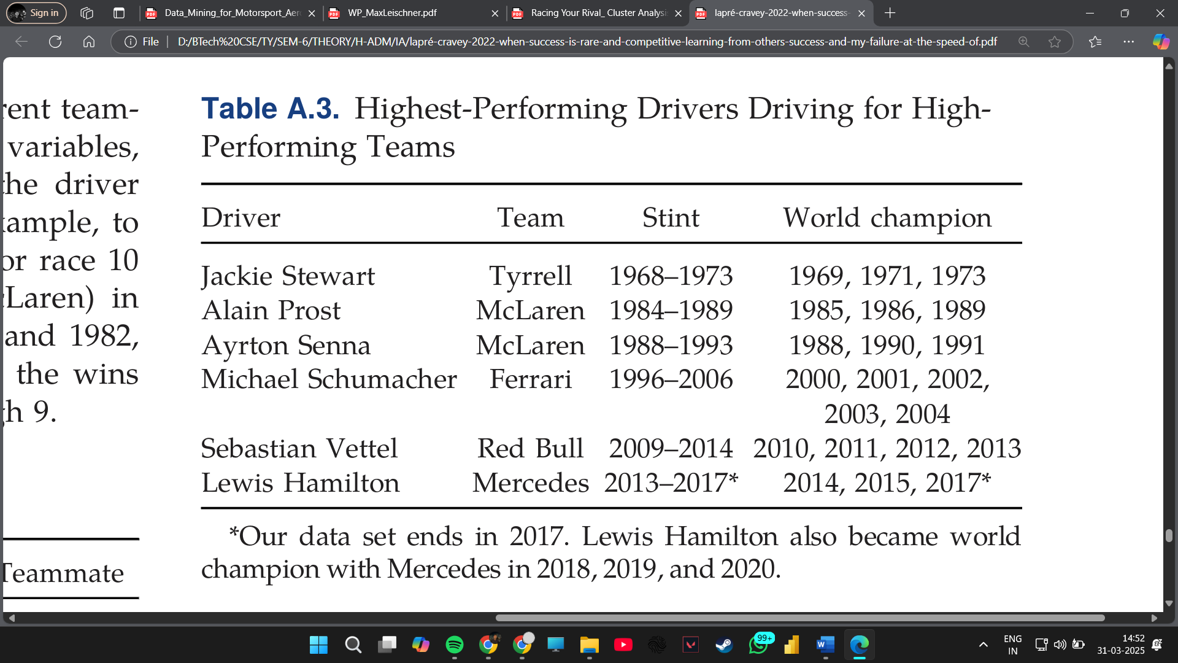

**Performance Evaluation and Results:**

* NLP techniques are used to extract insights from team radio transcripts and race debriefs.
* The study finds that teams systematically analyze competitors’ strategies to refine their own approaches.
* Learning from past failures and adapting strategies dynamically contribute to long-term success.
* The findings indicate that teams that leverage data-driven learning approaches consistently perform better over multiple seasons.

Additionally, reinforcement learning models have been used to enhance strategic adaptation. Teams now employ AI-driven simulations that learn from previous race outcomes and generate optimal pit stop and overtaking strategies.

The study highlights how predictive analytics can transform decision-making, enabling teams to react faster and more effectively during races. This underscores the increasing reliance on data-driven strategies in motorsport.

By integrating deep learning with race data analysis, F1 teams can gain a critical edge in competitive racing environments.

**4. Comparison Analysis**

**4.1. Machine learning for Motorsport Aerodynamics** *Research Paper: "Machine learning for Motorsport Aerodynamics" (Matthew Watts, Robert Carrese, Hadi Winarto, 2019)*

**4.1.1 Traditional Machine learning Approaches:** Traditional machine learning techniques in motorsport aerodynamics primarily relied on statistical models, regression techniques, and basic clustering algorithms. Principal Component Analysis (PCA) was often used to reduce the dimensionality of aerodynamic data, extracting the most significant variables affecting performance. Regression models, including linear and polynomial regression, helped in understanding the relationships between different aerodynamic components, such as downforce, drag, and airflow efficiency. Decision trees and basic rule-based systems were used for classification tasks, categorizing aerodynamic setups based on historical performance data.

K-means clustering was another commonly used technique, allowing engineers to group aerodynamic configurations based on similarity. This technique helped in identifying optimal setups for different track conditions. However, these traditional methods had limitations. PCA, while effective in dimensionality reduction, often led to loss of crucial aerodynamic nuances. Regression models struggled with non-linear relationships in aerodynamic interactions, and clustering methods lacked adaptability to dynamic environmental conditions.

**4.1.2 Modern Approaches Introduced:** With the rise of advanced machine learning techniques, motorsport aerodynamics has seen significant improvements in machine learning applications. Computational Fluid Dynamics (CFD) data is now integrated with machine learning algorithms to enhance aerodynamic predictions. Deep learning models, particularly Convolutional Neural Networks (CNNs), are being employed to analyze airflow patterns around the car, identifying optimal aerodynamic adjustments.

Reinforcement learning has also emerged as a powerful tool for aerodynamic optimization. By simulating various aerodynamic configurations and analyzing their impact on performance, reinforcement learning algorithms can iteratively improve design choices. Hybrid models combining physics-based simulations with data-driven insights provide a more comprehensive approach, ensuring accurate aerodynamic tuning in real-world conditions.

**4.1.3 Comparative Analysis:** Traditional machine learning techniques provided valuable but often static insights. The modern methods, leveraging deep learning and reinforcement learning, offer dynamic, real-time optimizations. These new techniques enhance the precision of aerodynamic adjustments, ultimately leading to improved lap times and efficiency.

**4.2. Predicting Formula 1 Compound Decisions** *Research Paper: "From Data to Podium: A Machine Learning Model for Predicting Formula 1 Compound Decisions" (Max Leischner, 2023)*

**4.2.1 Traditional Machine learning Approaches:** Tire compound decisions have historically been guided by basic predictive models using time-series analysis and linear regression. These models evaluated lap times, track temperature, and historical data to determine the optimal tire choice. Logistic regression was used to classify whether a soft or hard compound would be more effective under given conditions.

However, these models had several drawbacks. They failed to account for real-time changes in race dynamics, such as sudden weather shifts or unexpected safety car deployments. Additionally, they relied heavily on historical data, making them less adaptable to new regulations or track modifications.

**4.2.2 Modern Approaches Introduced:** Recent advancements have introduced machine learning techniques like Gradient Boosting Decision Trees (GBDT), Long Short-Term Memory (LSTM) networks, and Bayesian optimization. GBDT models, such as XGBoost, have demonstrated superior predictive performance by considering multiple interdependent factors, including driver behavior, fuel load, and evolving track conditions.

LSTM networks, a type of recurrent neural network (RNN), have been particularly effective in processing sequential race data. By analyzing past tire performance over multiple laps, LSTMs provide more accurate predictions on tire degradation and optimal pit stop timing. Bayesian optimization further refines predictions by dynamically adjusting model parameters based on live race data.

**4.2.3 Comparative Analysis:** Traditional methods provided a basic framework for tire strategy but lacked flexibility. Modern machine learning techniques incorporate real-time data streams, leading to more adaptive and accurate predictions. These improvements enhance race strategy decisions, minimizing tire degradation issues and maximizing race performance.

**4.3. Cluster Analysis of Formula 1 Drivers** *Research Paper: "Racing Your Rival: Cluster Analysis of Formula 1 Drivers" (Syracuse University, 2022)*

**4.3.1 Traditional Machine learning Approaches:** Traditional clustering methods in F1 driver analysis relied on hierarchical clustering and K-means algorithms. These techniques grouped drivers based on performance metrics such as lap times, overtakes, and qualifying positions. Factor analysis was employed to identify key attributes contributing to driver success.

Despite their utility, these methods had limitations. K-means clustering required predefined cluster numbers, which were often arbitrary. Hierarchical clustering struggled with scalability, making it inefficient for large datasets. Additionally, these methods failed to capture the dynamic nature of driver performance across varying race conditions.

**4.3.2 Modern Approaches Introduced:** Recent research has explored advanced clustering techniques such as Spectral Clustering, Gaussian Mixture Models (GMM), and Dynamic Time Warping (DTW). Spectral clustering has proven effective in handling high-dimensional driver performance data, allowing for more flexible and meaningful classifications. GMM offers soft clustering, enabling drivers to belong to multiple performance groups based on probabilistic distributions.

DTW, an algorithm for measuring similarity between time series data, has been instrumental in aligning race performance metrics across different race tracks and conditions. Unsupervised deep learning models, particularly autoencoders, have also been used to uncover hidden patterns in driver performance, offering insights beyond traditional statistics.

**4.3.3 Comparative Analysis:** Traditional clustering methods provided a basic segmentation of drivers but lacked adaptability. Modern techniques offer more nuanced and dynamic classifications, improving the understanding of driver capabilities and rivalries. These advancements contribute to better talent scouting and strategic team decisions.

**4.4. Competitive Learning in Formula One** *Research Paper: "When Success Is Rare and Competitive: Learning from Others’ Success and My Failure at the Speed of Formula One" (INFORMS, 2022)*

**4.4.1 Traditional Machine learning Approaches:** Competitive learning in F1 has traditionally relied on methods like Linear Discriminant Analysis (LDA) and decision trees. These approaches categorized performance outcomes based on predefined metrics such as podium finishes, race incidents, and lap consistency.

However, these traditional techniques lacked adaptability. They provided a static view of competition, failing to incorporate evolving strategies and real-time performance feedback. Additionally, they struggled to interpret the complex interdependencies between competitors’ actions and race outcomes.

**4.4.2 Modern Approaches Introduced:** Recent developments have introduced reinforcement learning and multi-agent deep learning models to competitive strategy analysis. Reinforcement learning allows teams to simulate various race strategies and learn optimal decision-making policies through trial and error.

Multi-agent deep learning models consider interactions between multiple competitors, enabling a more holistic analysis of competitive dynamics. Explainable AI (XAI) methods help interpret the reasoning behind strategic decisions, providing transparency in machine-generated insights. Transfer learning is also employed to adapt successful strategies across different race tracks and seasons.

**4.4.3 Comparative Analysis:** Traditional methods provided basic categorizations but lacked adaptability to dynamic race conditions. Modern approaches offer real-time adaptability, improving strategic decision-making and race performance predictions. These advancements allow teams to refine strategies more effectively and gain a competitive edge.

**Comparison Table**

| **Paper Title** | **Traditional Techniques** | **Modern Techniques** |
| --- | --- | --- |
| Machine learning for Motorsport Aerodynamics | PCA, Regression, Decision Trees, K-means | CNNs, Reinforcement Learning, CFD Integration |
| Predicting Formula 1 Compound Decisions | Time-Series Analysis, Logistic Regression | GBDT, LSTMs, Bayesian Optimization |
| Cluster Analysis of Formula 1 Drivers | K-means, Hierarchical Clustering | Spectral Clustering, GMM, DTW, Autoencoders |
| Competitive Learning in Formula One | LDA, Decision Trees | Reinforcement Learning, Multi-Agent Deep Learning, XAI, Transfer Learning |

**5. Future Scope**

**5.1. Future Scope of Machine learning in Motorsport Aerodynamics**

**Overview of the Paper**

The paper "Machine learning for Motorsport Aerodynamics" investigates how machine learning techniques can be applied to aerodynamic testing and analysis in motorsports. The study emphasizes the use of computational fluid dynamics (CFD), wind tunnel testing, and track data to enhance car performance.

**Future Scope**

1. **Real-time Aerodynamic Optimization:** One of the most promising advancements in motorsport aerodynamics is the application of real-time machine learning algorithms. Current aerodynamic testing methods rely on pre-race simulations and controlled wind tunnel tests. However, by utilizing real-time machine learning, engineers can gather live telemetry data and adjust the car's aerodynamic setup during the race weekend. Machine learning models can be trained on historical race data to predict aerodynamic performance under varying weather and track conditions. These AI-driven optimizations could dynamically adjust elements like wing angles, drag reduction system (DRS) configurations, and airflow management strategies.
2. **AI-driven CFD Simulations:** Traditional CFD simulations require significant computational resources and time. Machine learning techniques can optimize these simulations by identifying patterns in historical aerodynamic testing results. Machine learning models, such as deep neural networks, can be trained to approximate CFD outputs, significantly reducing the time required to test new aerodynamic configurations. AI-based surrogate models can allow teams to conduct rapid aerodynamic evaluations without the need for extensive computational fluid dynamics runs, improving the speed and efficiency of design iterations.
3. **Automated Aero-Testing Pipelines:** Implementing automated machine learning workflows can help streamline aerodynamic testing processes. With the integration of machine learning techniques, teams can develop self-learning models that continuously refine aerodynamic testing parameters. These models can analyze test results in real-time and suggest improvements, reducing manual intervention and increasing efficiency. By using unsupervised learning methods, engineers can also cluster aerodynamic data to identify optimal configurations based on track-specific conditions.
4. **Sensor-Driven Performance Enhancements:** Modern Formula 1 cars are equipped with thousands of sensors that collect real-time data on various aerodynamic parameters. By applying advanced machine learning algorithms, teams can extract actionable insights from these massive datasets. Predictive analytics can help engineers understand how minor setup changes affect overall aerodynamic efficiency. Furthermore, real-time sensor data can be processed using AI-driven analytics platforms to provide instantaneous feedback, enabling rapid decision-making during race weekends.
5. **Integration with Digital Twins:** The concept of digital twins involves creating a virtual replica of an F1 car to simulate performance in real-time. By integrating machine learning techniques with digital twin technology, teams can accurately predict aerodynamic failures and make necessary adjustments before they impact race performance. Digital twins can use real-time telemetry data, combined with machine learning models, to simulate the effects of different aerodynamic setups. This allows teams to test multiple configurations in a virtual environment, reducing on-track testing time and improving overall efficiency.

**5.2. Future Scope of Machine Learning for Predicting Formula 1 Compound Decisions**

**Overview of the Paper**

The research paper "From Data to Podium: A Machine Learning Model for Predicting Formula 1 Compound Decisions" explores how historical race data can be leveraged to develop machine learning models for optimizing tire strategies.

**Future Scope**

1. **Advanced Deep Learning Models:** Current tire compound selection strategies rely on historical race data and track-specific characteristics. However, deep learning models can further enhance prediction accuracy by analyzing a combination of weather forecasts, real-time track conditions, and previous race performances. Convolutional Neural Networks (CNNs) and Recurrent Neural Networks (RNNs) can process historical and real-time telemetry data to predict optimal tire compounds dynamically.
2. **Adaptive Race Strategy Adjustments:** AI models can be trained to update race strategies in real-time based on live telemetry data. A reinforcement learning-based system could analyze competitor pit stops, degradation rates, and race incidents to recommend optimal tire changes. These models would enable teams to react proactively rather than reactively, leading to improved race outcomes.
3. **Personalized Driver-Tire Interaction Models:** Each driver has a unique driving style that affects tire wear. By using clustering algorithms and decision trees, machine learning models can create personalized tire selection models for each driver. These models could analyze braking, acceleration, and cornering patterns to recommend the best tire compound suited to individual driving techniques.
4. **Multi-agent Decision-making Systems:** Formula 1 races involve multiple teams and competitors making strategic decisions simultaneously. A multi-agent AI system can simulate different strategic scenarios, predicting the likely responses of rival teams to various tire choices. By understanding opponent strategies in real-time, teams can optimize their decisions to gain a competitive edge.
5. **Simulation-Based Predictive Analytics:** Virtual simulations powered by machine learning can help teams test various tire strategies under simulated race conditions before making real-time decisions. AI-driven simulation models can predict how different tire compounds will behave over race distances, allowing teams to plan optimal pit stop windows and maximize performance.

**5.3. Future Scope of Cluster Analysis for Formula 1 Drivers**

**Overview of the Paper**

The paper "Racing Your Rival: Cluster Analysis of Formula 1 Drivers" applies cluster analysis to categorize Formula 1 drivers based on performance metrics, driving styles, and strategic decisions.

**Future Scope**

1. **Driver Classification Enhancements:** Advanced clustering techniques, such as hierarchical clustering and deep clustering networks, can provide more precise driver performance categorizations.
2. **AI-based Driver Matchmaking:** Machine learning can be used to compare new drivers with historical performance clusters, assisting teams in scouting future talent.
3. **Race Strategy Adaptation:** Cluster-based insights can help teams dynamically adapt race strategies based on historical rival behaviors.
4. **Automated Rivalry Analysis:** The integration of real-time cluster analysis can allow teams to assess competitor strategies and develop counter-strategies during races.
5. **Longitudinal Performance Tracking:** Machine learning models can be trained to identify performance trends across multiple seasons, predicting potential career trajectories for drivers.

**5.4. Future Scope of Learning from Competitor Success and Failure in Formula 1**

**Overview of the Paper**

The study "When Success Is Rare and Competitive: Learning from Others’ Success and My Failure at the Speed of Formula One" investigates the impact of competitive benchmarking and performance analysis in Formula 1.

**Future Scope**

1. **AI-Driven Competitive Benchmarking:** Machine learning algorithms can be used to continuously analyze the successes and failures of rival teams to inform strategy adjustments.
2. **Predictive Performance Models:** Teams can employ predictive analytics to anticipate success rates based on historical race data and strategic decision-making patterns.
3. **Failure Pattern Recognition:** The use of anomaly detection models can help identify failure trends, preventing recurring performance issues.
4. **Data-Driven Sponsorship Insights:** Machine learning can be applied to assess the impact of performance on sponsorship deals, optimizing financial and marketing strategies.
5. **Cross-Team Knowledge Transfer:** AI-driven analytics can identify knowledge gaps within teams, suggesting improvements based on competitor data trends.

**6. Conclusion**

Machine learning has revolutionized Formula 1, enhancing aerodynamics, tire strategy, driver performance analysis, and strategic decision-making. The research papers reviewed in this report highlight how machine learning and advanced data analytics are reshaping the sport, allowing teams to optimize performance and refine strategies dynamically.

Aerodynamic analysis benefits from computational fluid dynamics (CFD) and machine learning, reducing reliance on costly wind tunnel tests. Predictive modeling enables teams to simulate airflow patterns and improve car designs, leading to better downforce and reduced drag. Tire strategy optimization leverages historical race data, track conditions, and weather to predict optimal compound choices, minimizing unnecessary pit stops and maximizing performance.

Driver performance analysis, using clustering techniques, helps teams assess strengths, weaknesses, and adaptability under different conditions. Understanding rival drivers’ tendencies allows for more strategic race planning. Additionally, strategic learning models, such as reinforcement learning and Bayesian inference, enhance decision-making by continuously adapting to real-time race conditions.

While machine learning offers significant advantages, challenges such as data privacy, computational demands, and ethical concerns must be addressed. As artificial intelligence and big data continue to evolve, Formula 1 will further integrate these technologies, ensuring that data-driven decision-making remains at the core of its competitive success.

**7. References**

1. Watts, M., Carrese, R., & Winarto, H. (2021). *Machine learning for Motorsport Aerodynamics*. [InTechOpen]
2. Leischner, M. (2023). *From Data to Podium: A Machine Learning Model for Predicting Formula 1 Compound Decisions*. [Universidade Nova de Lisboa]
3. Syracuse University (2022). *Racing Your Rival: Cluster Analysis of Formula 1 Drivers*. [Syracuse Honors Capstone]
4. INFORMS (2022). *When Success Is Rare and Competitive: Learning from Others’ Success and My Failure at the Speed of Formula One*. [Management Science]